

SCHOOL OF FUTURE TECH

Case Study Report

On

Harbor Lane Legal Group
Network Foundations, Topology & IP Addressing Design

Computer Networks

By Daksh Srivastava - 150096725087

CASE STUDY REPORT

HARBOR LANE LEGAL GROUP

Network Foundations, Topology & IP Addressing Design
Computer Networking
Submitted By:
Daksh Srivastava
Roll / ID: 150096725087
Tools Used: Cisco Packet Tracer
Project Type: Enterprise Network Design and Implementation

TABLE OF CONTENTS

- Abstract
- Introduction
- Problem Statement
- Project Objectives
- Network Requirements Analysis
- Physical Network Topology Design
- WAN Connectivity
- VLAN Implementation
- Inter-VLAN Routing Implementation
- IP Addressing Design
- Voice VLAN Implementation
- Network Testing and Verification
- Network Protocol Explanation
- OSI Model Mapping
- Private and Public IP Addressing
- Final Network Topology
- Conclusion
- Future Improvements

1. ABSTRACT
This project focuses on designing and implementing an enterprise network infrastructure for Harbor Lane Legal Group. The organization requires a reliable and scalable network connecting its Head Office with two branch offices, Riverside and Uptown.
The proposed network uses VLAN segmentation to separate the major departments at the Head Office. VLSM is used to allocate IPv4 addresses according to the host requirements of each network segment. Router-on-a-Stick is implemented to provide communication between VLANs, while trunk links carry multiple VLANs between the core and departmental switches.
The network also includes serial WAN leased-line connectivity between the Head Office and branch offices. A dedicated Voice VLAN is implemented for VoIP communication, with DHCP providing automatic IP addressing to the IP phone.
The complete network was designed, configured, and tested using Cisco Packet Tracer. Connectivity was verified using gateway ping tests, inter-VLAN communication tests, WAN connectivity tests, DHCP verification, interface status verification, and routing-table inspection.

2. INTRODUCTION
Modern organizations require secure, scalable, and reliable computer networks to support daily operations. A legal organization such as Harbor Lane Legal Group handles sensitive information and therefore requires proper network segmentation, controlled communication, reliable connectivity, and an organized IP addressing structure.
The organization consists of a Head Office and two satellite offices:
- Head Office
- Riverside Office
- Uptown Office
The Head Office contains four major departments:
- Litigation Department
- Corporate Law Department
- IT & Records Department
- Reception/Admin Department
Each major Head Office department is assigned a separate VLAN. This logical separation reduces unnecessary broadcast traffic and provides a structured foundation for network management.
The network also supports printers, employee systems, a VoIP phone, and WAN connectivity to the two branch offices. The overall implementation follows an extended-star architecture at the Head Office with serial point-to-point WAN connections to the branches.

3. PROBLEM STATEMENT
Harbor Lane Legal Group is expanding its operations and requires a properly planned network infrastructure before deploying networking equipment.
The network design must provide:
- Separate networks for different departments
- Efficient IP address allocation
- Communication between departments when required
- Connectivity between Head Office and branch offices
- Support for printers and VoIP devices
- Reliable network connectivity
- Easy troubleshooting and management
- Scope for future expansion
The network should minimize unnecessary broadcast traffic while maintaining communication between required network segments.

4. PROJECT OBJECTIVES
The main objectives of this project are:

4.1 Network Segmentation
Separate the major departments using VLANs to logically isolate their network traffic.

4.2 Efficient IP Address Management
Use VLSM to allocate subnet sizes according to the number of required hosts while maintaining spare capacity.

4.3 Inter-VLAN Communication
Implement Router-on-a-Stick to allow communication between different VLANs through the Head Office router.

4.4 WAN Connectivity
Establish point-to-point serial WAN connections between the Head Office and Riverside and Uptown offices.

4.5 Voice Communication
Create a dedicated Voice VLAN for the IP phone and provide automatic addressing using DHCP.

4.6 Network Verification
Verify the implementation using:
- Ping tests
- DHCP verification
- Interface status
- Routing-table verification
- Inter-VLAN communication
- WAN connectivity tests
These objectives correspond to the implemented network architecture and testing evidence in the project.

5. NETWORK REQUIREMENTS ANALYSIS
The network requirements provided for the case study are:
Network Segment | Required Hosts | Purpose
HO – Litigation | 45 | Attorney laptops and e-discovery workstations
HO – Corporate Law | 33 | Corporate legal employees
HO – IT & Records | 9 | IT resources and records management
HO – Reception/Admin | 4 | Reception and administrative devices
HO – Riverside WAN | 2 | Point-to-point WAN connection
HO – Uptown WAN | 2 | Point-to-point WAN connection
A dedicated Voice VLAN was additionally implemented to support the VoIP phone located in Reception/Admin.

6. PHYSICAL NETWORK TOPOLOGY DESIGN

6.1 Topology Recommendation
The implemented Head Office network follows an Extended Star Topology.
A central core switch acts as the backbone of the Head Office. Departmental access switches connect to the core switch, while end devices connect to their respective departmental switches.
The Head Office router performs:
- Inter-VLAN routing
- VLAN gateway functions
- WAN connectivity
- Voice VLAN gateway functions
The branch offices use a smaller star-based LAN arrangement connected through their respective routers.
This architecture provides:
- Easy addition of new devices
- Centralized network management
- Easier troubleshooting
- Departmental traffic separation
- Predictable connectivity paths
- Reasonable fault isolation
A failure of an individual access link normally affects the connected device or segment, while the core switch and Head Office router remain critical infrastructure components.

6.2 Base Network Device Placement
The initial Packet Tracer workspace was created by placing the routers, switches, and end devices required for the enterprise network.
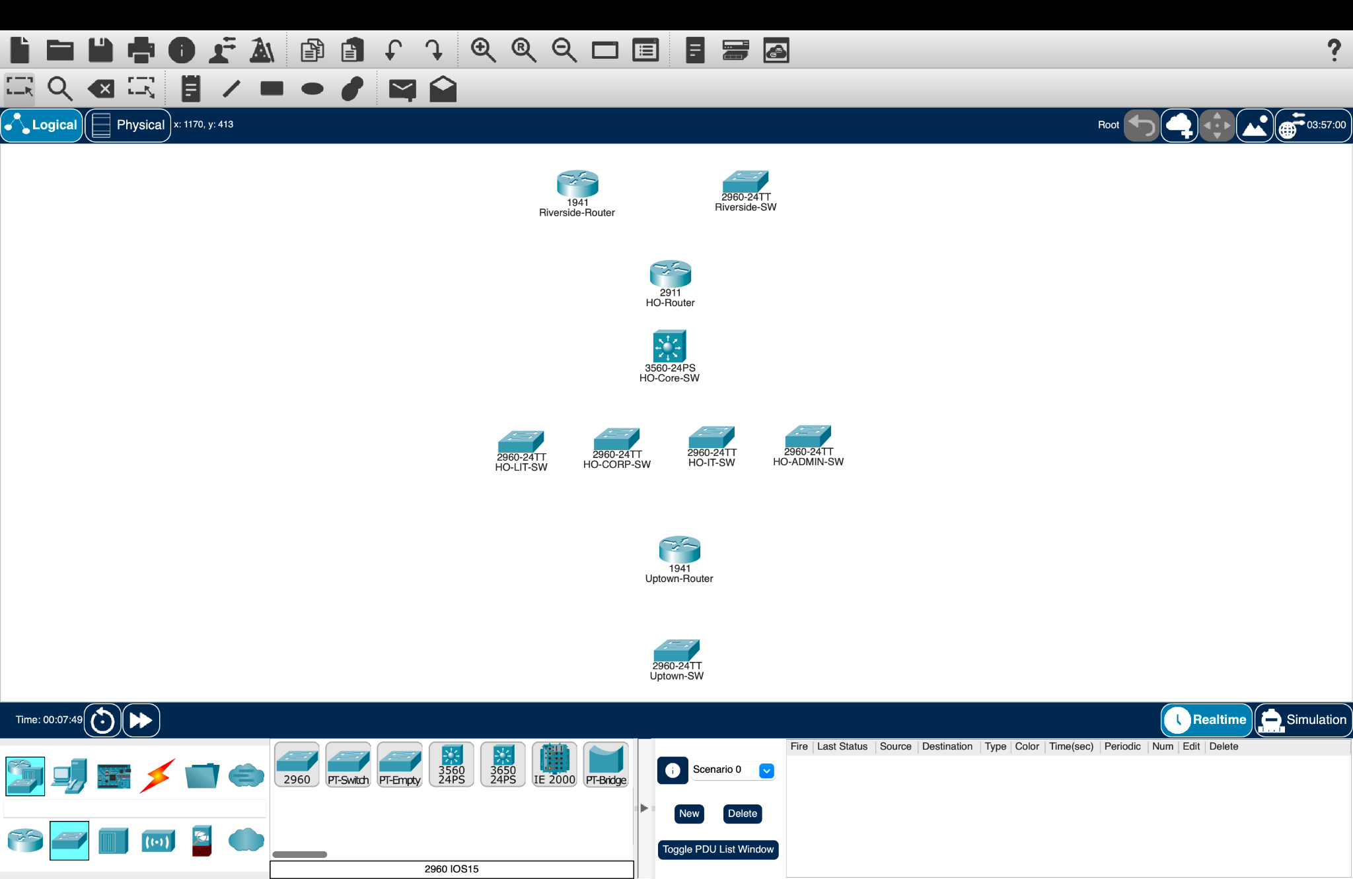
Figure 1: Initial Packet Tracer topology showing the placement of routers, switches, and network devices.

6.3 End Device Placement
The departmental end devices were placed according to the network requirements. These include employee laptops, desktop systems, printers, and the IP phone.
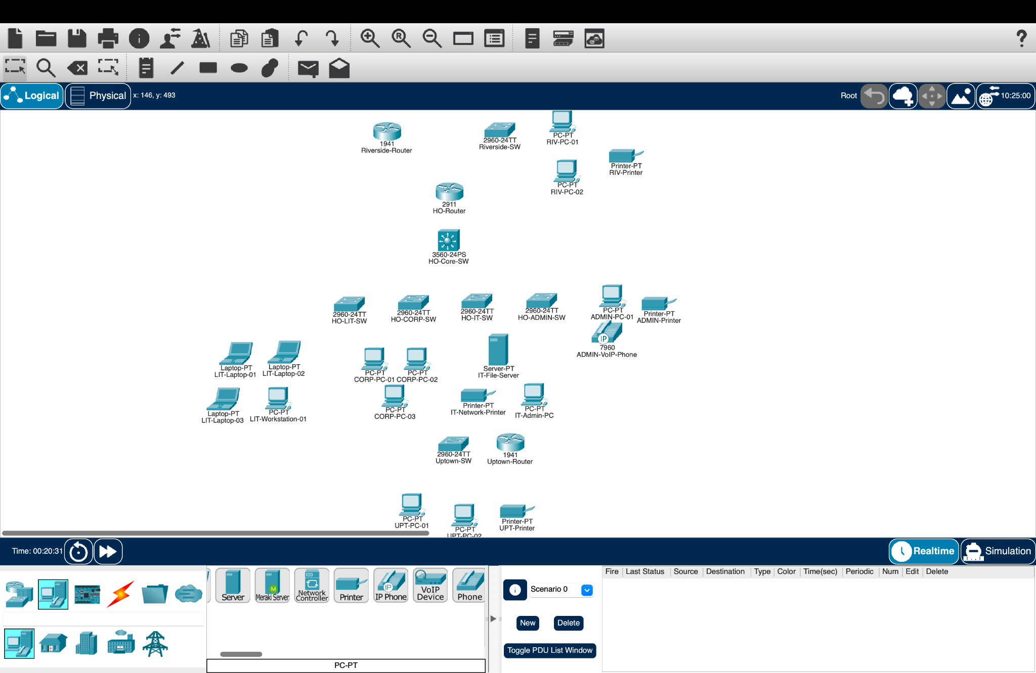
Figure 2: Placement of end devices across the different departments.

7. HEAD OFFICE BACKBONE AND DEPARTMENTAL NETWORKS

7.1 Head Office Backbone
The Head Office uses a centralized backbone design.
The core switch connects:
- Litigation Switch
- Corporate Law Switch
- IT & Records Switch
- Reception/Admin Switch
- Head Office Router
Trunk connectivity is used to carry VLAN traffic between the relevant network devices.
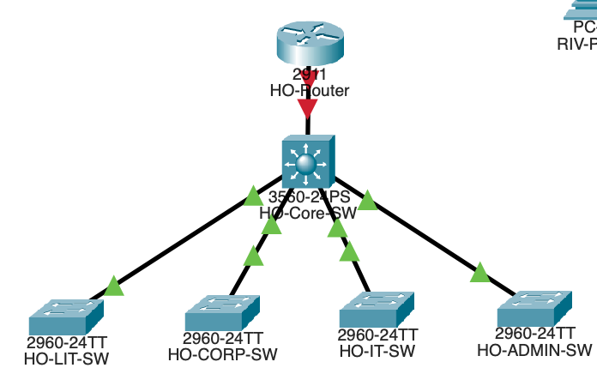
Figure 3: Head Office backbone connections between the core switch, router, and departmental switches.

7.2 Litigation Department
The Litigation Department contains attorney and workstation devices connected through a dedicated access switch.
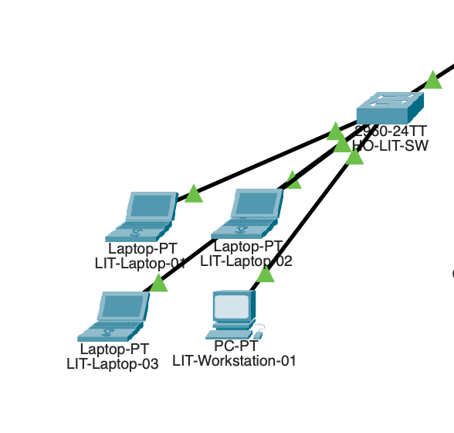
Figure 4: HO-LIT-SW and connected Litigation department devices.

7.3 Corporate Law Department
The Corporate Law Department is connected through a dedicated departmental switch, providing a separate logical network segment.
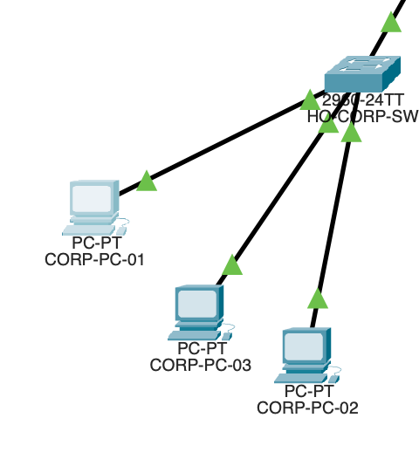
Figure 5: HO-CORP-SW and Corporate Law department connections.

7.4 IT & Records Department
The IT & Records Department contains the systems used for technical resources and records management.
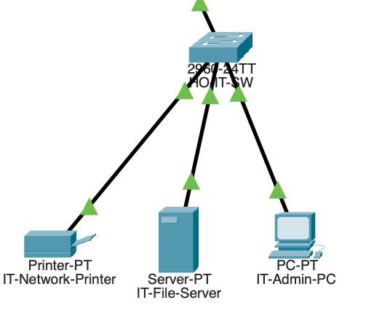
Figure 6: HO-IT-SW and IT & Records department connectivity.

7.5 Reception/Admin Department
The Reception/Admin Department supports administrative devices, a printer, and the VoIP phone.
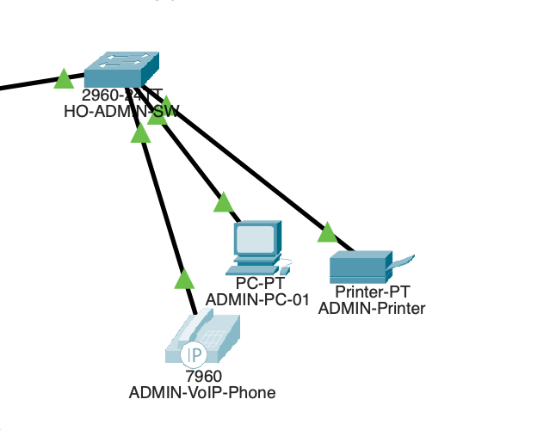
Figure 7: HO-ADMIN-SW and Reception/Admin device connections.

8. BRANCH OFFICE NETWORK DESIGN

8.1 Riverside Office
The Riverside branch follows a small star-based LAN architecture consisting of a router, switch, and connected end devices.
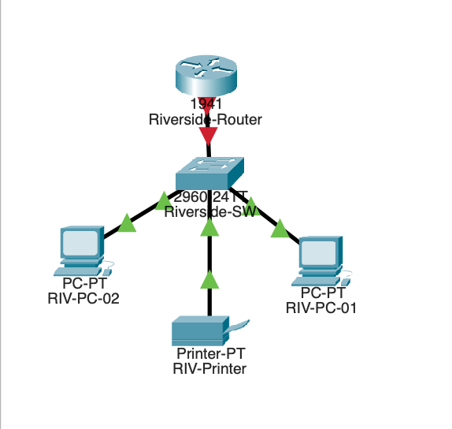
Figure 8: Riverside branch LAN connections.

8.2 Uptown Office
The Uptown branch follows a similar small LAN architecture consisting of a router, switch, and connected end devices.
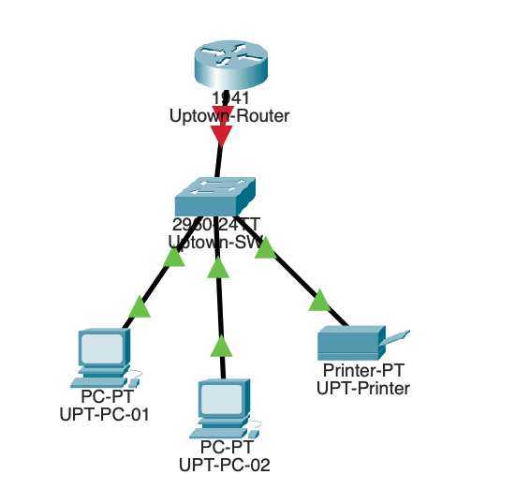
Figure 9: Uptown branch LAN connections.

9. WAN CONNECTIVITY

9.1 Serial Module Installation
The Head Office router was prepared for serial WAN connectivity by installing a suitable serial interface module.
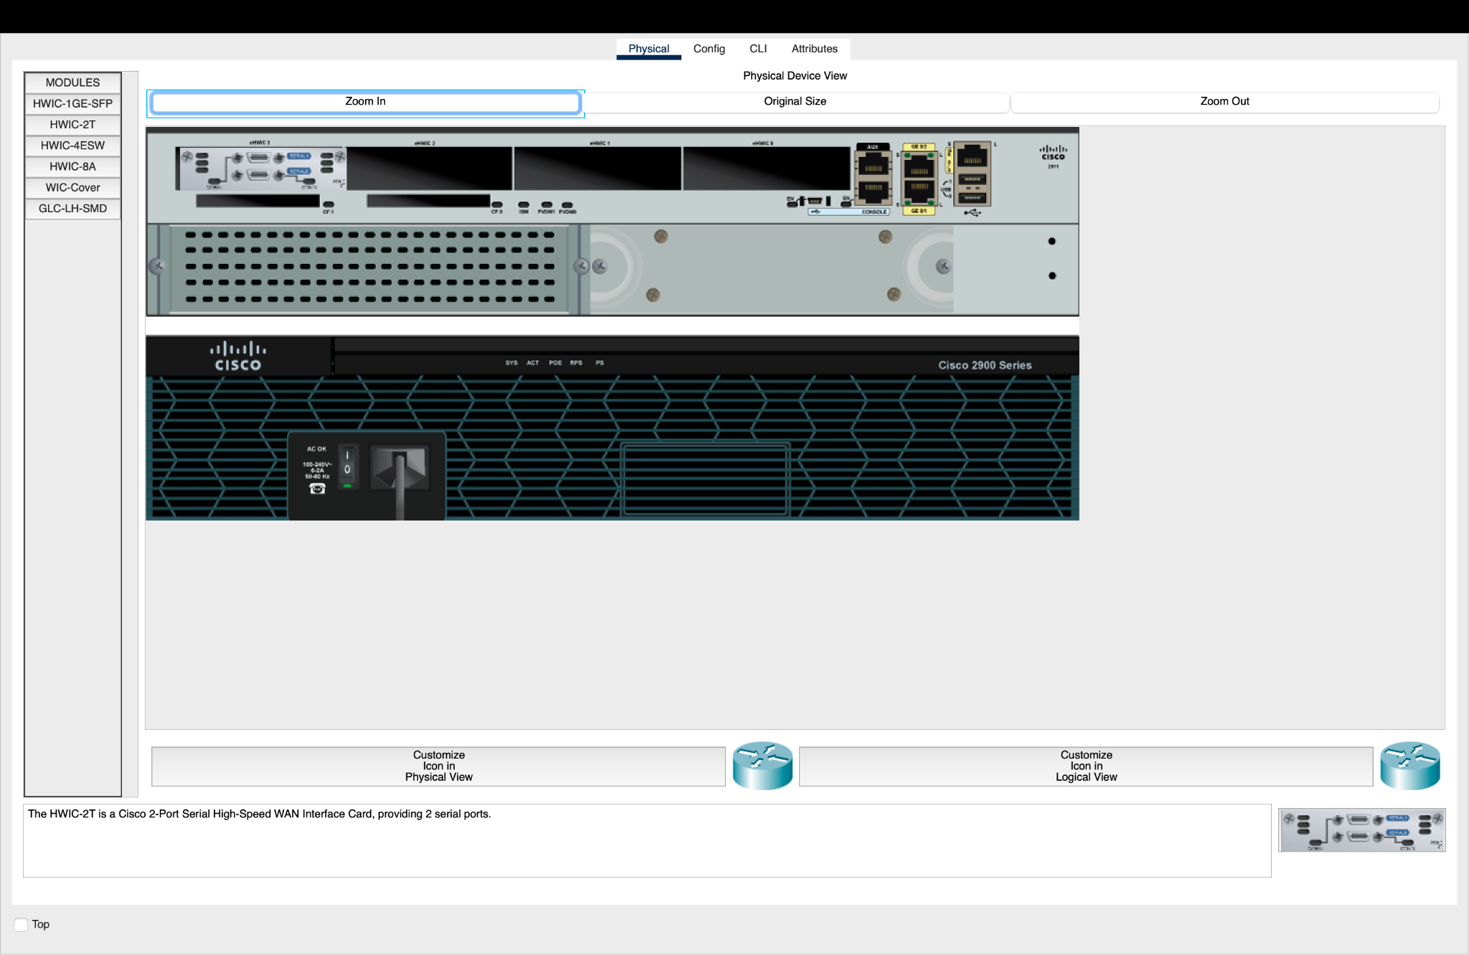
Figure 10: Installation of the HWIC-2T serial interface module on the Head Office router.

9.2 WAN Physical Connectivity
The Head Office is connected to Riverside and Uptown using serial point-to-point leased-line connections.
The WAN routers are:
- HO-Router
- Riverside-Router
- Uptown-Router
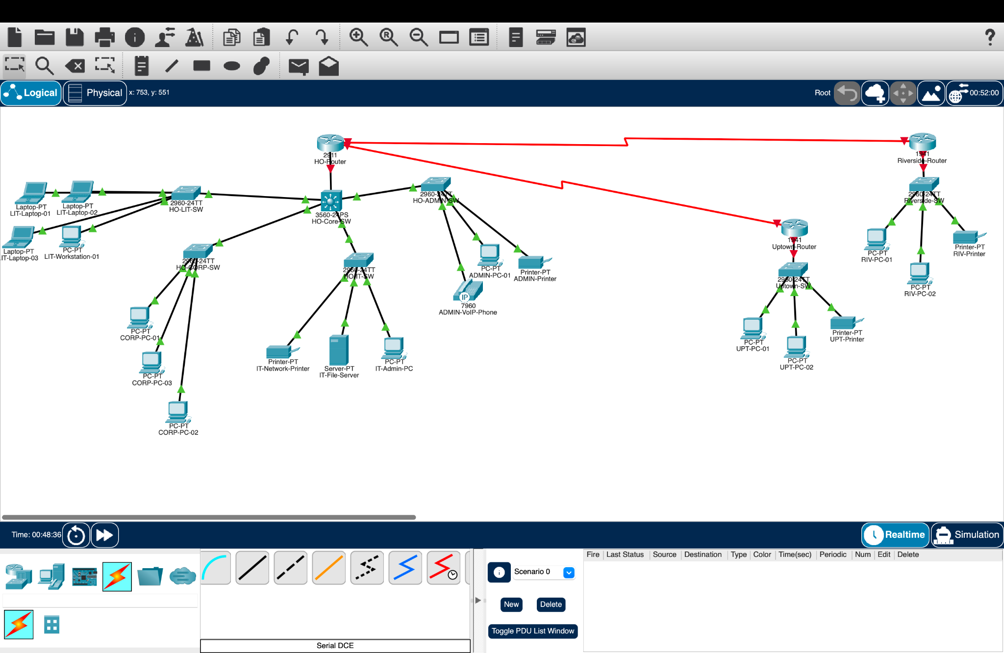
Figure 11: Physical serial WAN connections between the three office routers.

9.3 Head Office WAN Interface Configuration
The Head Office router uses two serial interfaces:
Interface | IP Address | Purpose
Serial0/3/0 | 192.168.43.1/30 | HO → Riverside
Serial0/3/1 | 192.168.43.5/30 | HO → Uptown
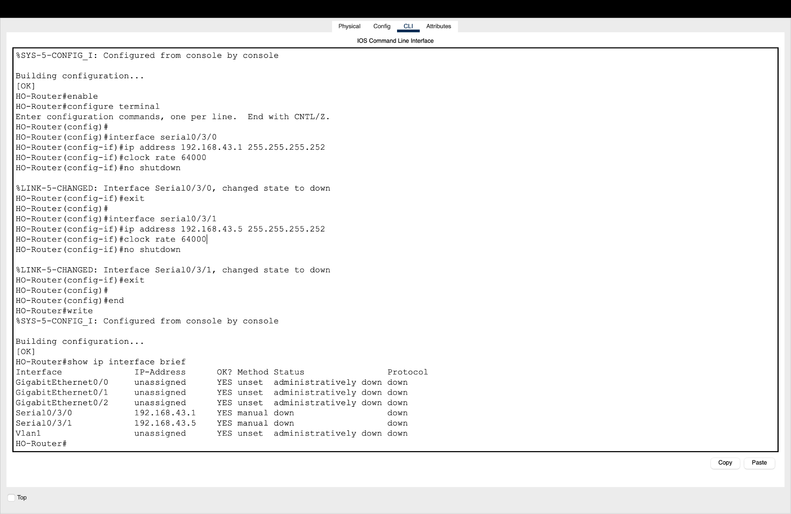
Figure 12: HO-Router serial WAN interface configuration.

9.4 Riverside WAN Interface
The Riverside router uses:
Serial0/1/0 — 192.168.43.2/30
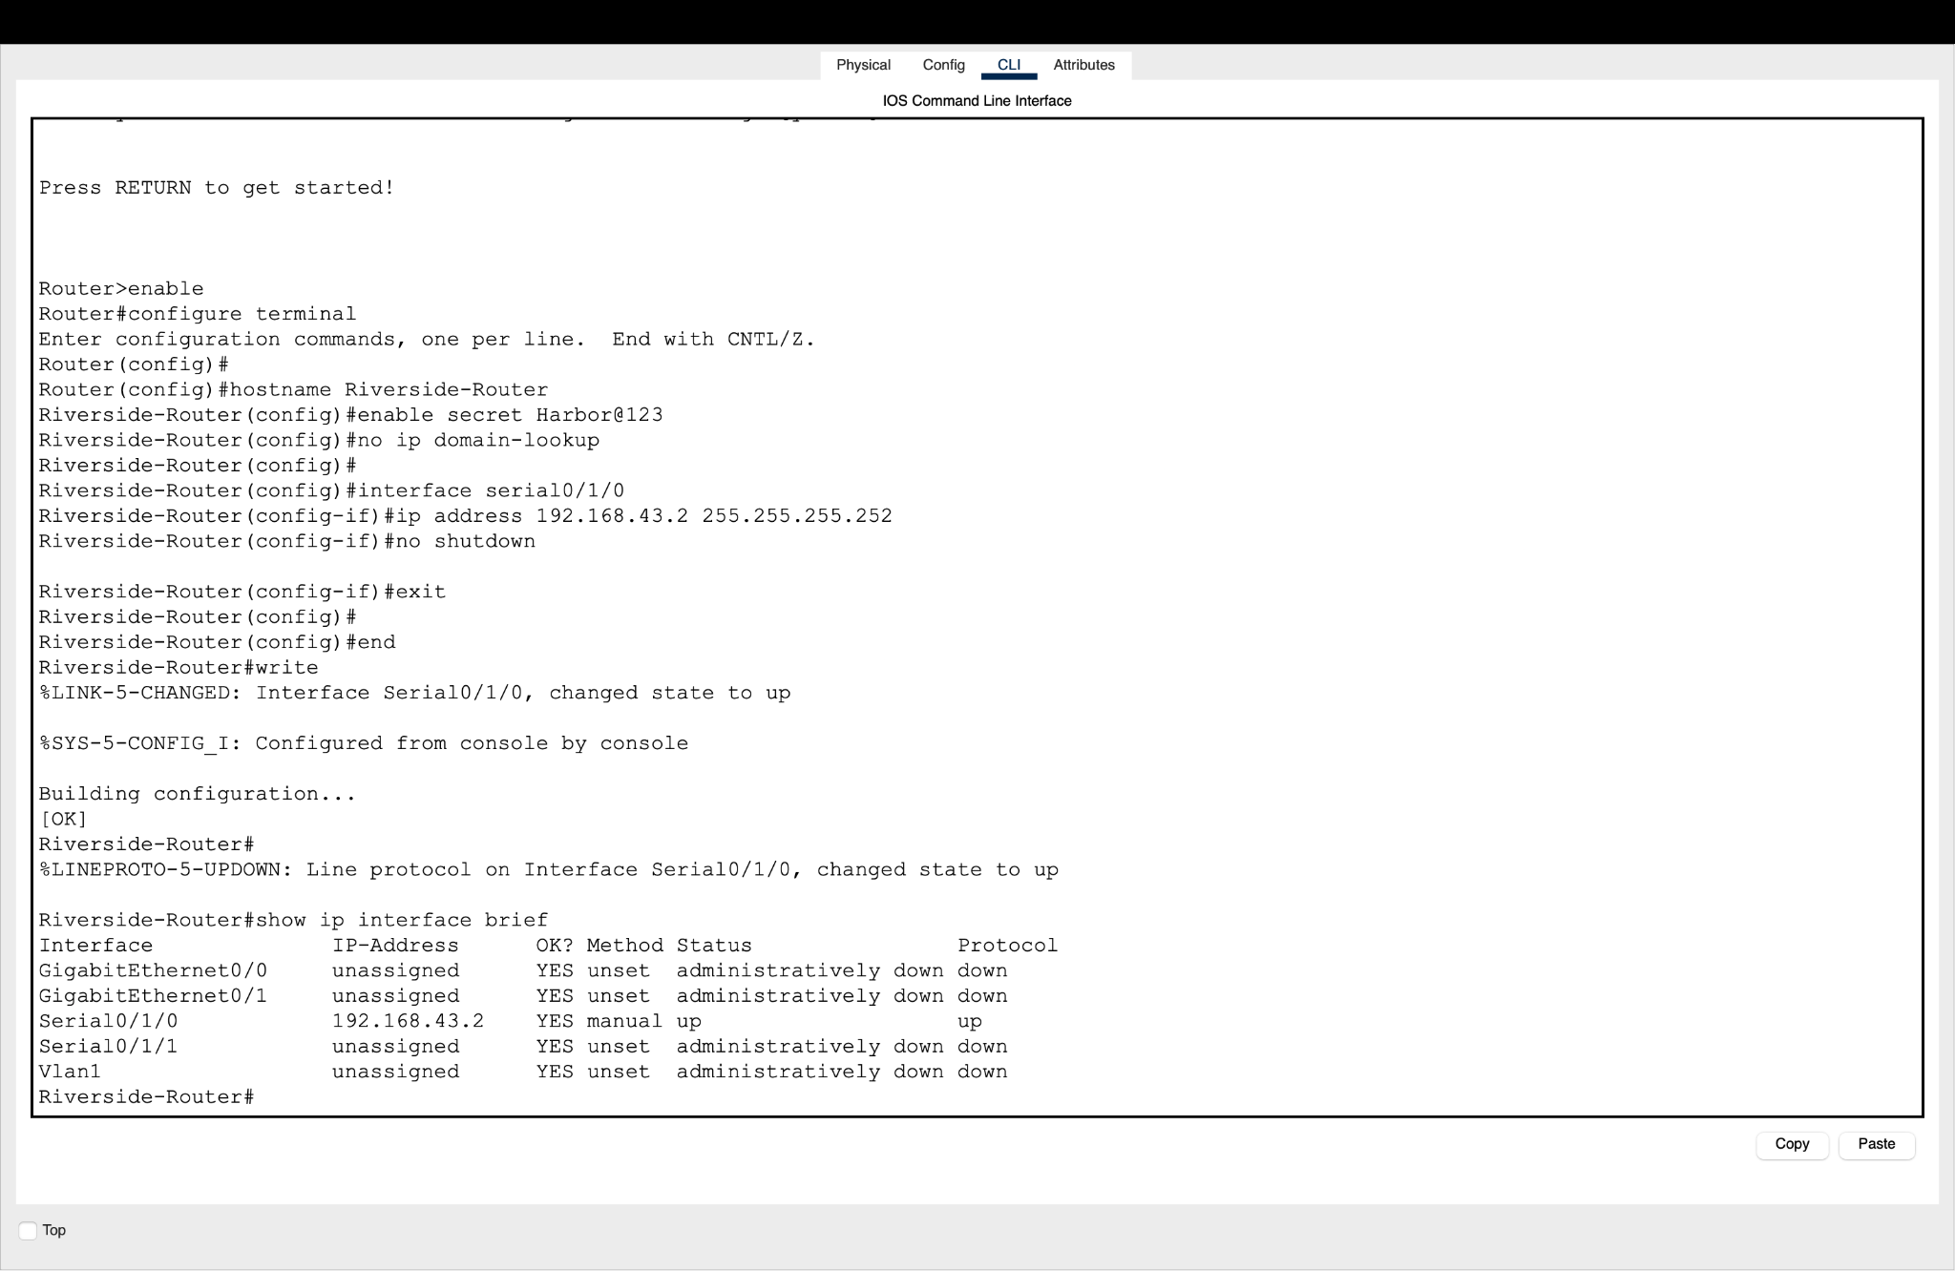
Figure 13: Riverside-Router WAN interface configuration.

9.5 Uptown WAN Interface
The Uptown router uses:
Serial0/1/0 — 192.168.43.6/30
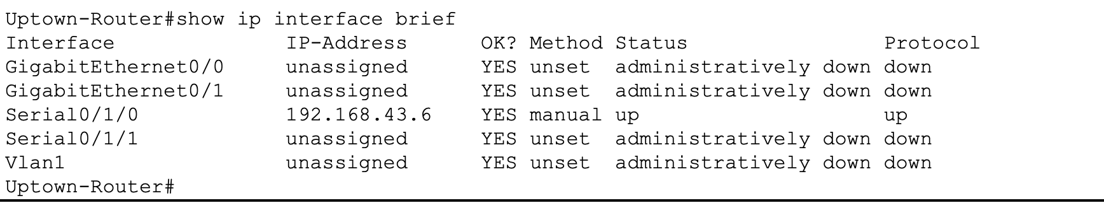
Figure 14: Uptown-Router WAN interface configuration.

9.6 WAN Connectivity Verification
The WAN links were verified using ICMP ping tests.
The Head Office router successfully reached:
- Riverside: 192.168.43.2
- Uptown: 192.168.43.6
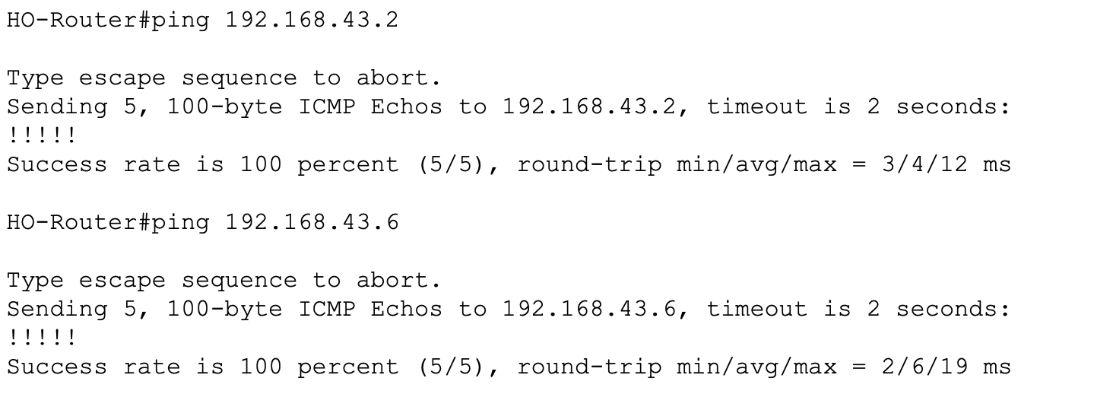
Figure 15: WAN connectivity verification between the Head Office and branch routers.

10. VLAN IMPLEMENTATION
VLAN segmentation was implemented at the Head Office.
VLAN ID | VLAN Name | Purpose
10 | LITIGATION | Litigation Department
20 | CORPORATE | Corporate Law Department
30 | IT | IT & Records
40 | ADMIN | Reception/Admin
50 | VOICE | IP Phone
VLANs allow the organization to separate traffic logically while using the same physical switching infrastructure.

10.1 Core Switch VLAN Creation
The required VLANs were created on the Head Office core switching infrastructure.
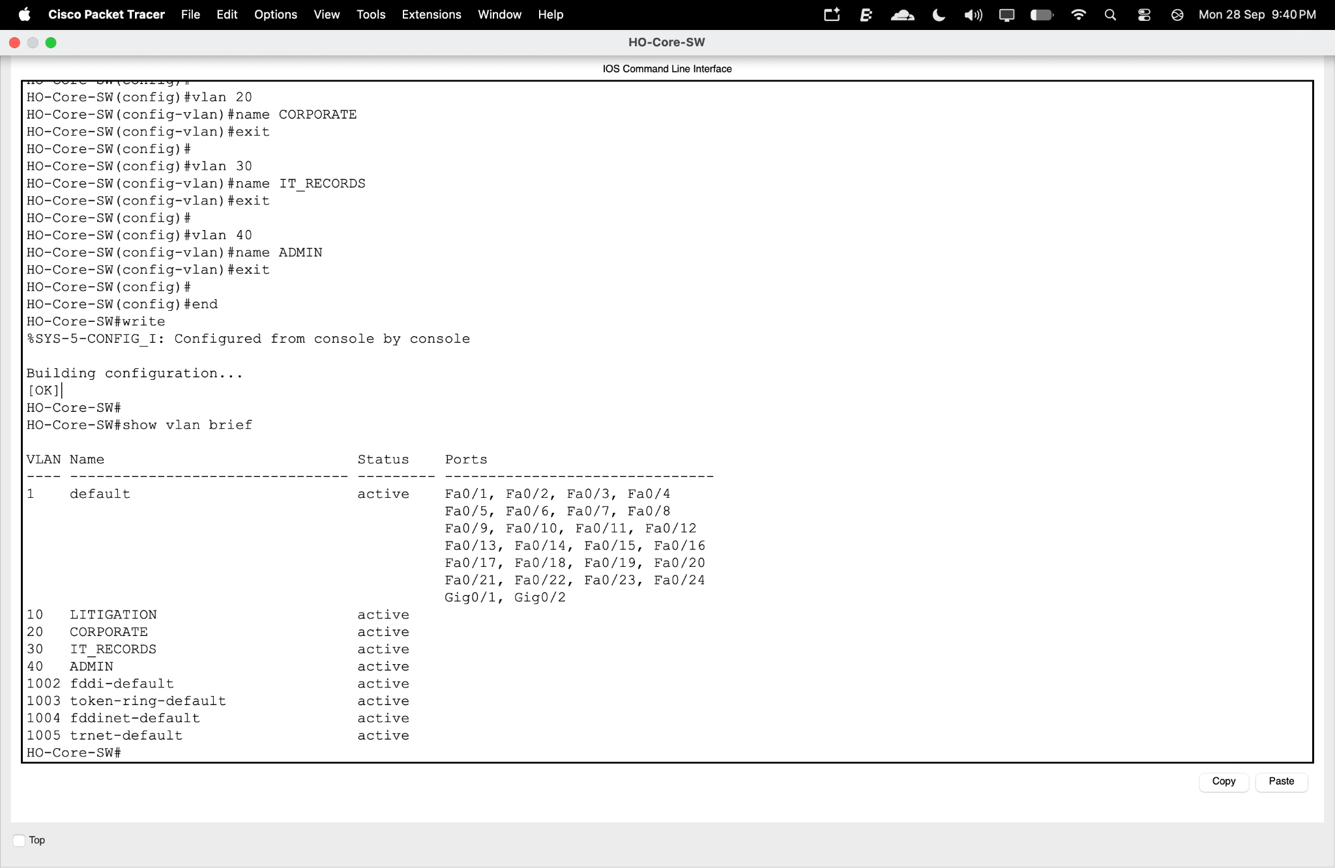
Figure 16: VLAN creation on the Head Office core switch.

10.2 Litigation VLAN Configuration
VLAN 10 was configured for the Litigation Department.
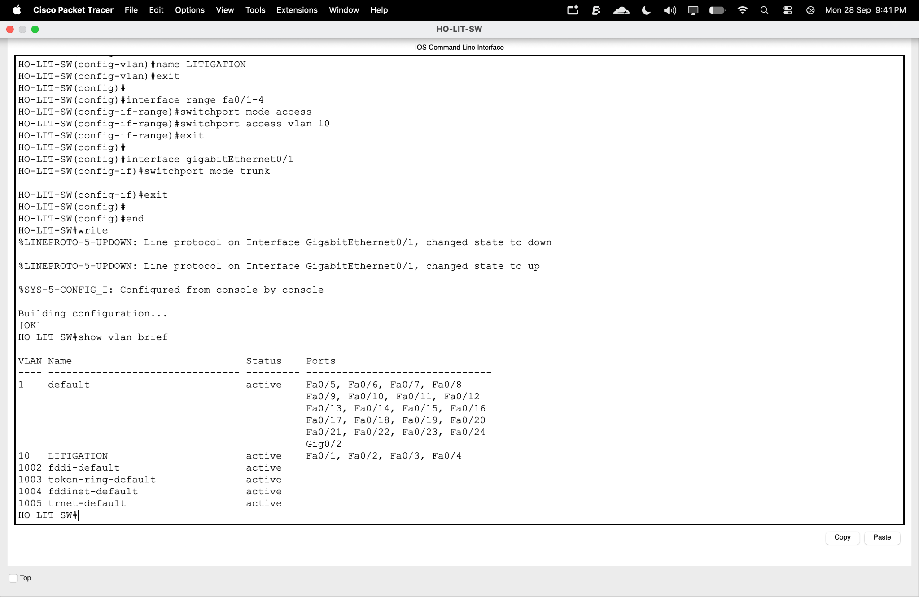
Figure 17: Litigation switch VLAN configuration.

10.3 Corporate VLAN Configuration
VLAN 20 was configured for the Corporate Law Department.
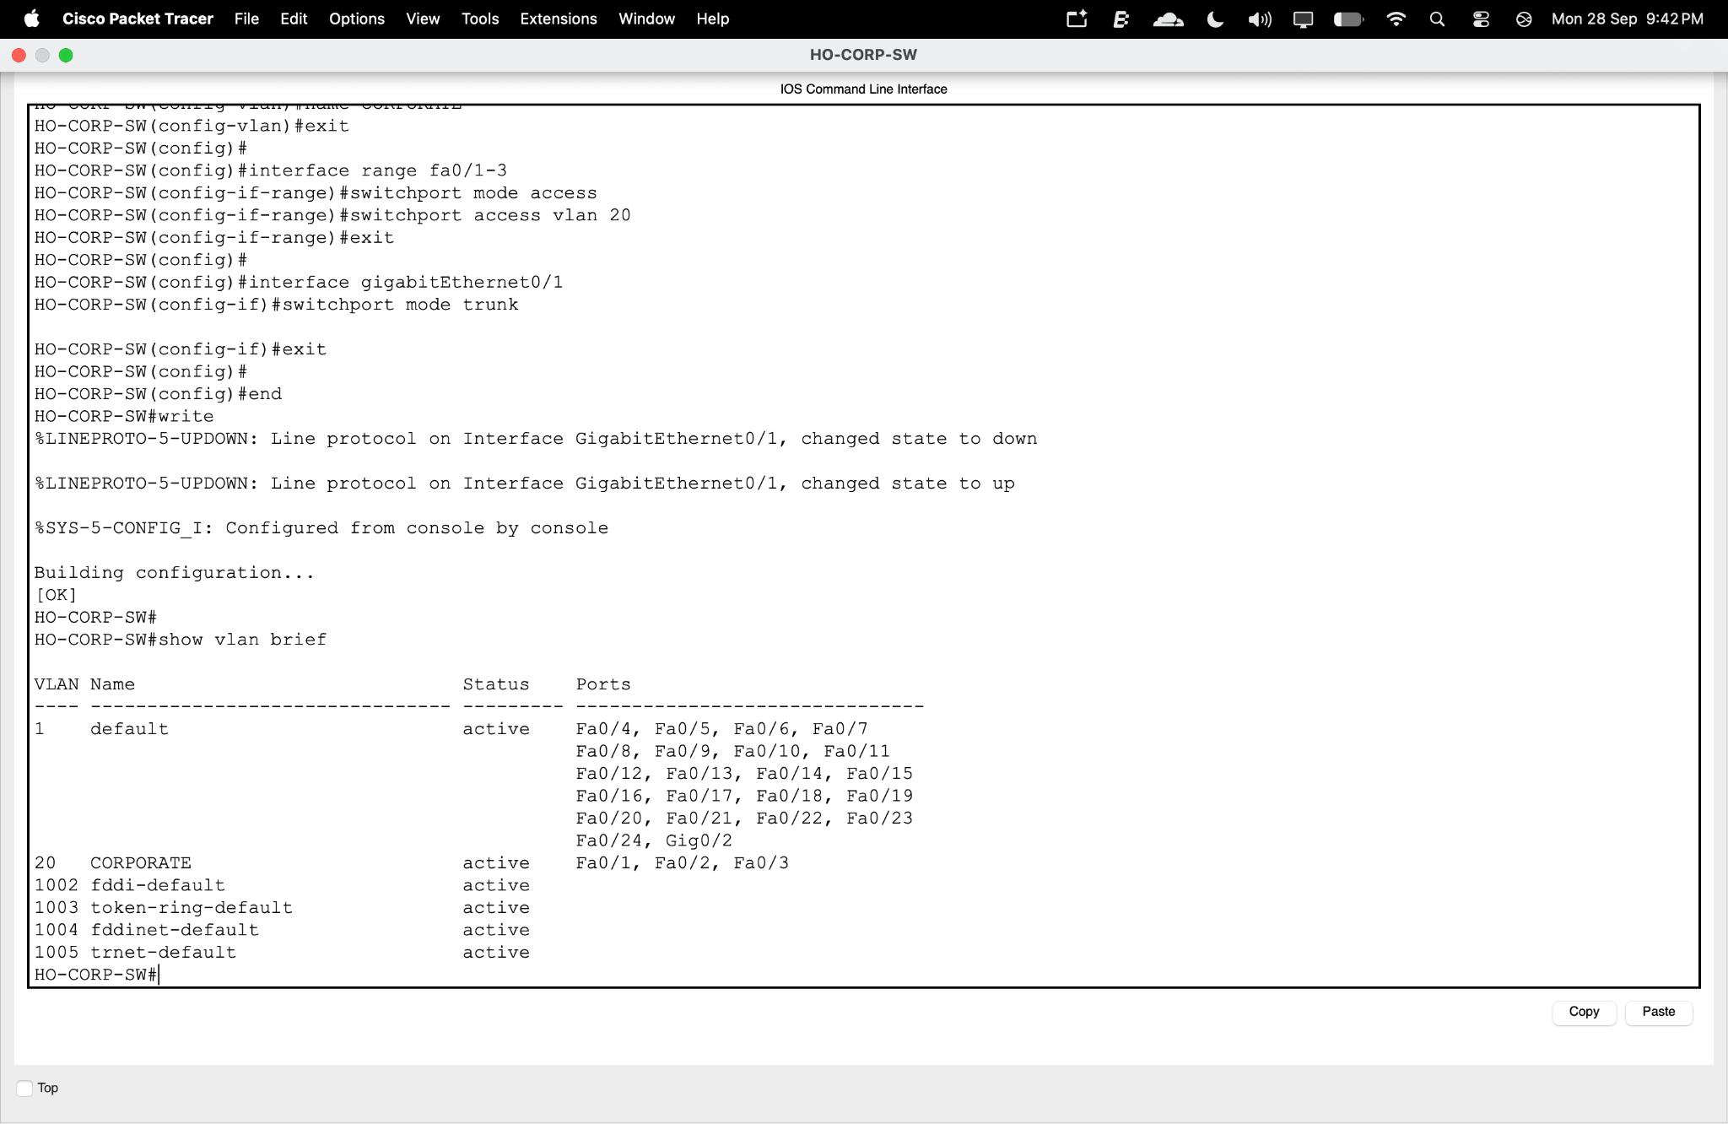
Figure 18: Corporate Law switch VLAN configuration.

10.4 IT & Records VLAN Configuration
VLAN 30 was configured for the IT & Records Department.
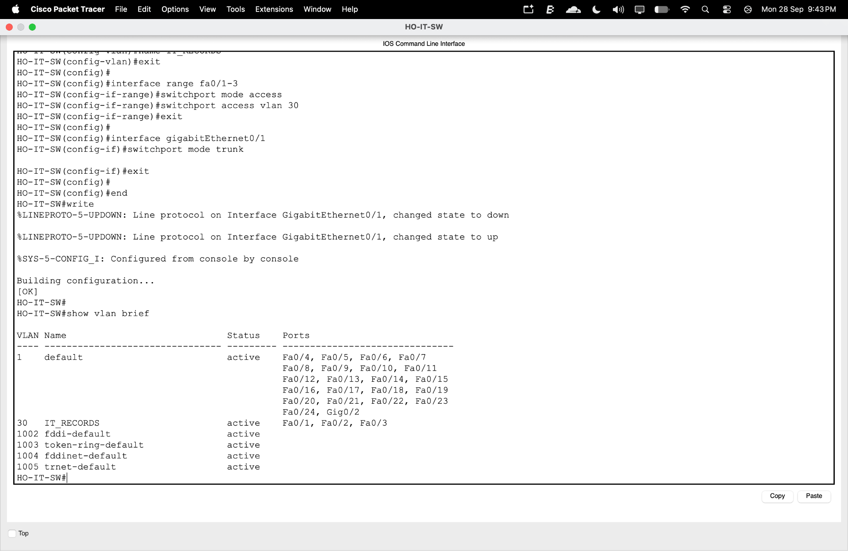
Figure 19: IT & Records switch VLAN configuration.

10.5 Reception/Admin VLAN Configuration
VLAN 40 was configured for Reception/Admin devices.
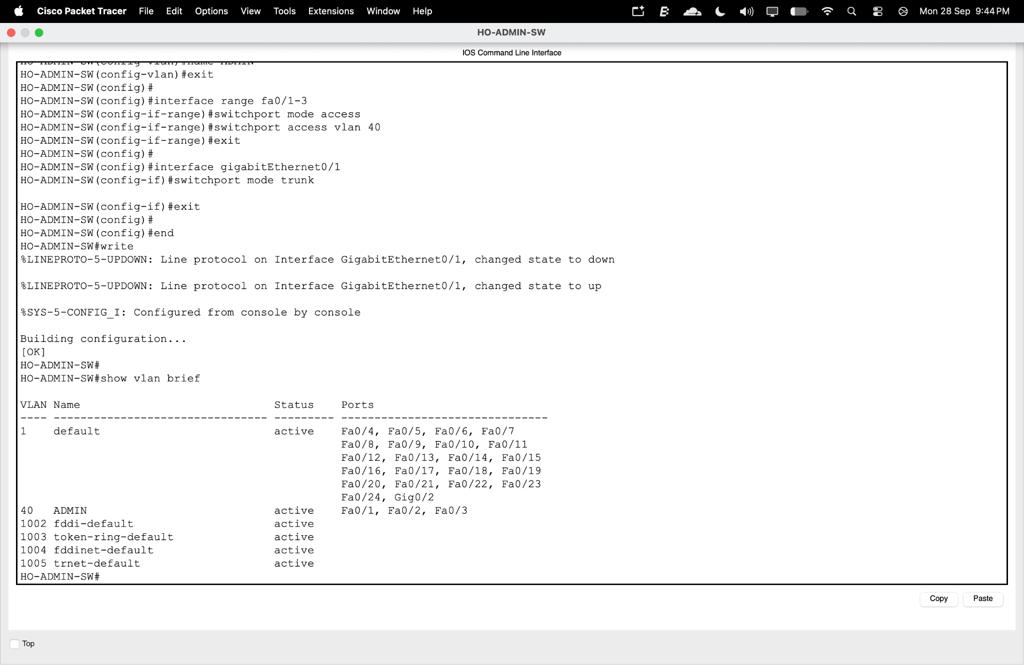
Figure 20: Reception/Admin switch VLAN configuration.

11. INTER-VLAN ROUTING IMPLEMENTATION

11.1 Router-on-a-Stick Configuration
Router-on-a-Stick was used to provide Layer 3 communication between the VLANs.
The Head Office router uses subinterfaces on GigabitEthernet0/0.
Subinterface | VLAN | Gateway | Network
G0/0.10 | 10 | 192.168.40.1 | 192.168.40.0/26
G0/0.20 | 20 | 192.168.40.65 | 192.168.40.64/26
G0/0.30 | 30 | 192.168.40.129 | 192.168.40.128/28
G0/0.40 | 40 | 192.168.40.145 | 192.168.40.144/28
G0/0.50 | 50 | 192.168.40.161 | 192.168.40.160/28
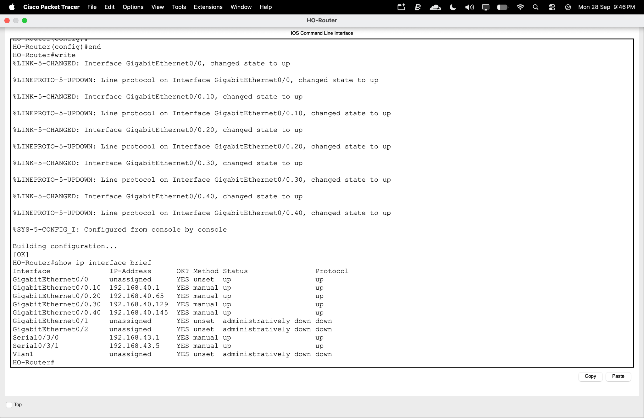
Figure 21: Router-on-a-Stick subinterface configuration on HO-Router.

11.2 Core Switch Trunk Configuration
The core switch trunk was configured to carry the required VLAN traffic.
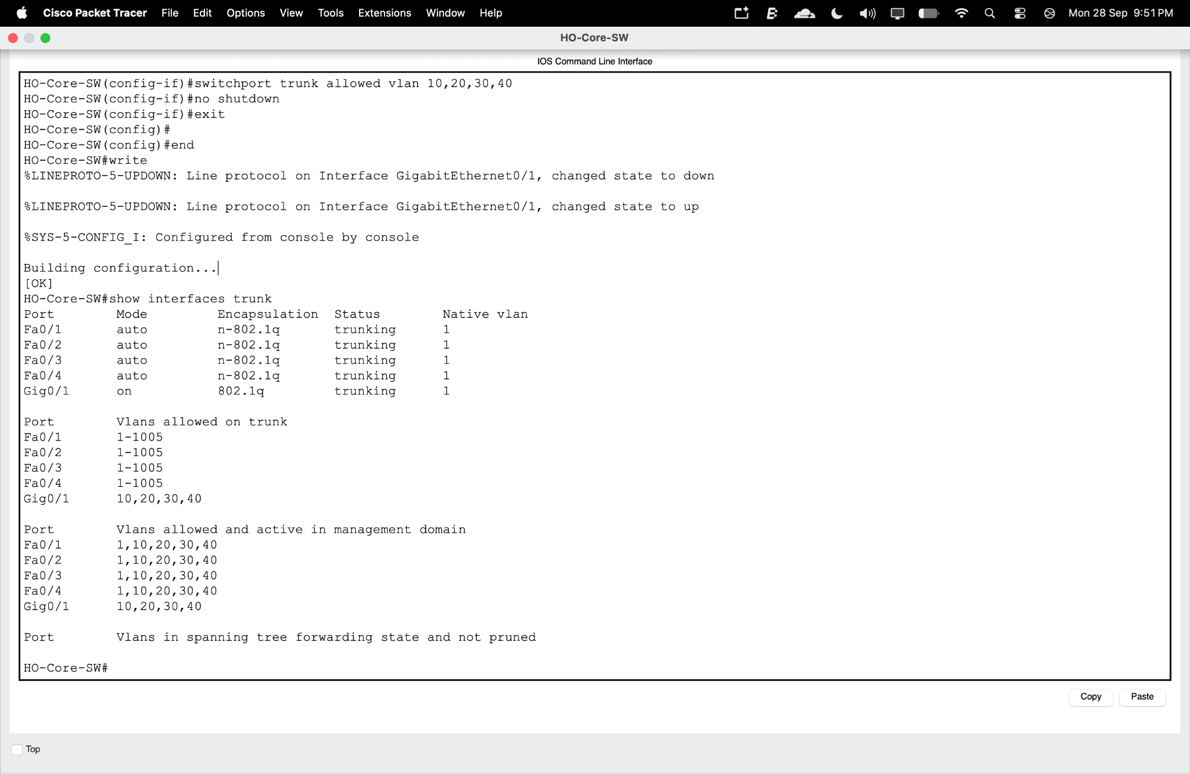
Figure 22: Initial trunk configuration on the Head Office core switch.

12. IP ADDRESSING DESIGN

12.1 Base Network
The assigned base IPv4 network is:

192.168.40.0/22
The /22 network provides the address space:
192.168.40.0 – 192.168.43.255
VLSM is used to divide this address space into appropriately sized subnets according to the host requirements.

13. VLSM ADDRESS ALLOCATION

13.1 LAN VLSM Address Allocation
For each LAN segment, the required host count is increased by 20% to provide spare capacity.
Network Segment | Hosts | +20% | Network / CIDR | Subnet Mask
Litigation VLAN 10 | 45 | 54 | 192.168.40.0/26 | 255.255.255.192
Corporate VLAN 20 | 33 | 40 | 192.168.40.64/26 | 255.255.255.192
IT & Records VLAN 30 | 9 | 11 | 192.168.40.128/28 | 255.255.255.240
Reception/Admin VLAN 40 | 4 | 5 | 192.168.40.144/28 | 255.255.255.240
Voice VLAN 50 | VoIP | — | 192.168.40.160/28 | 255.255.255.240

VLSM Calculation
Litigation:
45 × 1.20 = 54 required hosts
A /26 provides 62 usable addresses.
Corporate Law:
33 × 1.20 = 39.6 ≈ 40 required hosts
A /26 provides 62 usable addresses.
IT & Records:
9 × 1.20 = 10.8 ≈ 11 required hosts
A /28 provides 14 usable addresses.
Reception/Admin:
4 × 1.20 = 4.8 ≈ 5 required hosts.
A /29 would technically provide 6 usable addresses; however, the implemented Packet Tracer network uses /28, providing 14 usable addresses and additional room for administrative devices.
Voice VLAN:
The Voice VLAN uses a /28 subnet to provide 14 usable addresses for VoIP devices.

13.2 Host Range and Gateway
Network Segment | Usable Host Range | Broadcast | Gateway
Litigation VLAN 10 | 192.168.40.1 – 192.168.40.62 | 192.168.40.63 | 192.168.40.1
Corporate VLAN 20 | 192.168.40.65 – 192.168.40.126 | 192.168.40.127 | 192.168.40.65
IT & Records VLAN 30 | 192.168.40.129 – 192.168.40.142 | 192.168.40.143 | 192.168.40.129
Reception/Admin VLAN 40 | 192.168.40.145 – 192.168.40.158 | 192.168.40.159 | 192.168.40.145
Voice VLAN 50 | 192.168.40.161 – 192.168.40.174 | 192.168.40.175 | 192.168.40.161

13.3 WAN Address Allocation
WAN Link | Network / CIDR | Usable Addresses | Broadcast
HO – Riverside | 192.168.43.0/30 | 192.168.43.1 – 192.168.43.2 | 192.168.43.3
HO – Uptown | 192.168.43.4/30 | 192.168.43.5 – 192.168.43.6 | 192.168.43.7
A /30 subnet is appropriate for a point-to-point WAN connection because it provides exactly two usable IPv4 addresses, one for each router interface.

14. END DEVICE IP ADDRESS CONFIGURATION

14.1 Litigation Device
The Litigation laptop was configured with:
Parameter | Value
Device | LIT-Laptop-01
IP Address | 192.168.40.10
Subnet Mask | 255.255.255.192
Default Gateway | 192.168.40.1
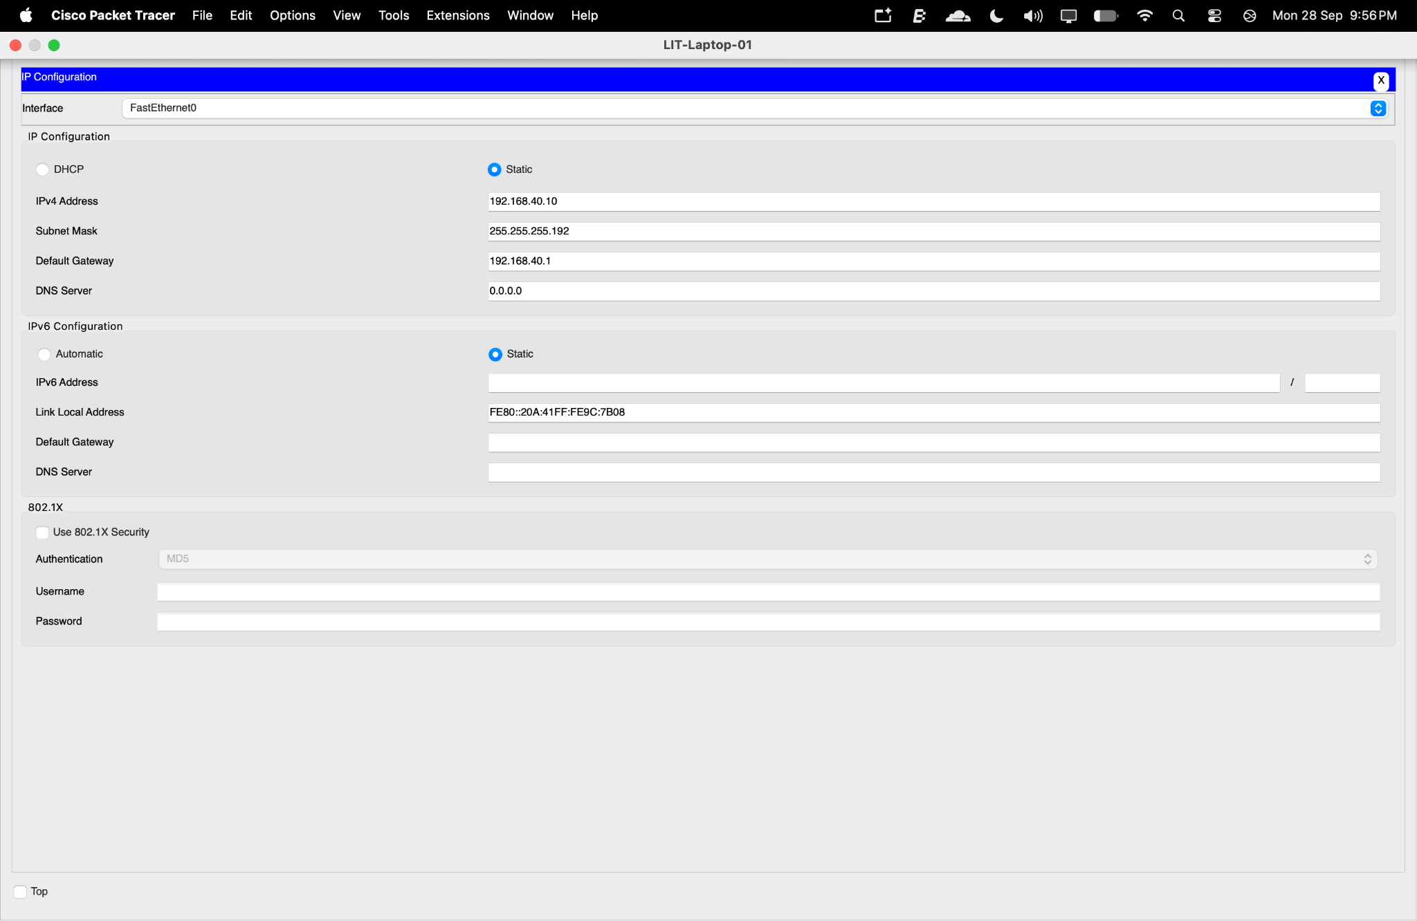
Figure 23: IP configuration of LIT-Laptop-01.

14.2 Corporate Device
The Corporate Law PC was configured with:
Parameter | Value
Device | CORP-PC-01
IP Address | 192.168.40.70
Subnet Mask | 255.255.255.192
Default Gateway | 192.168.40.65
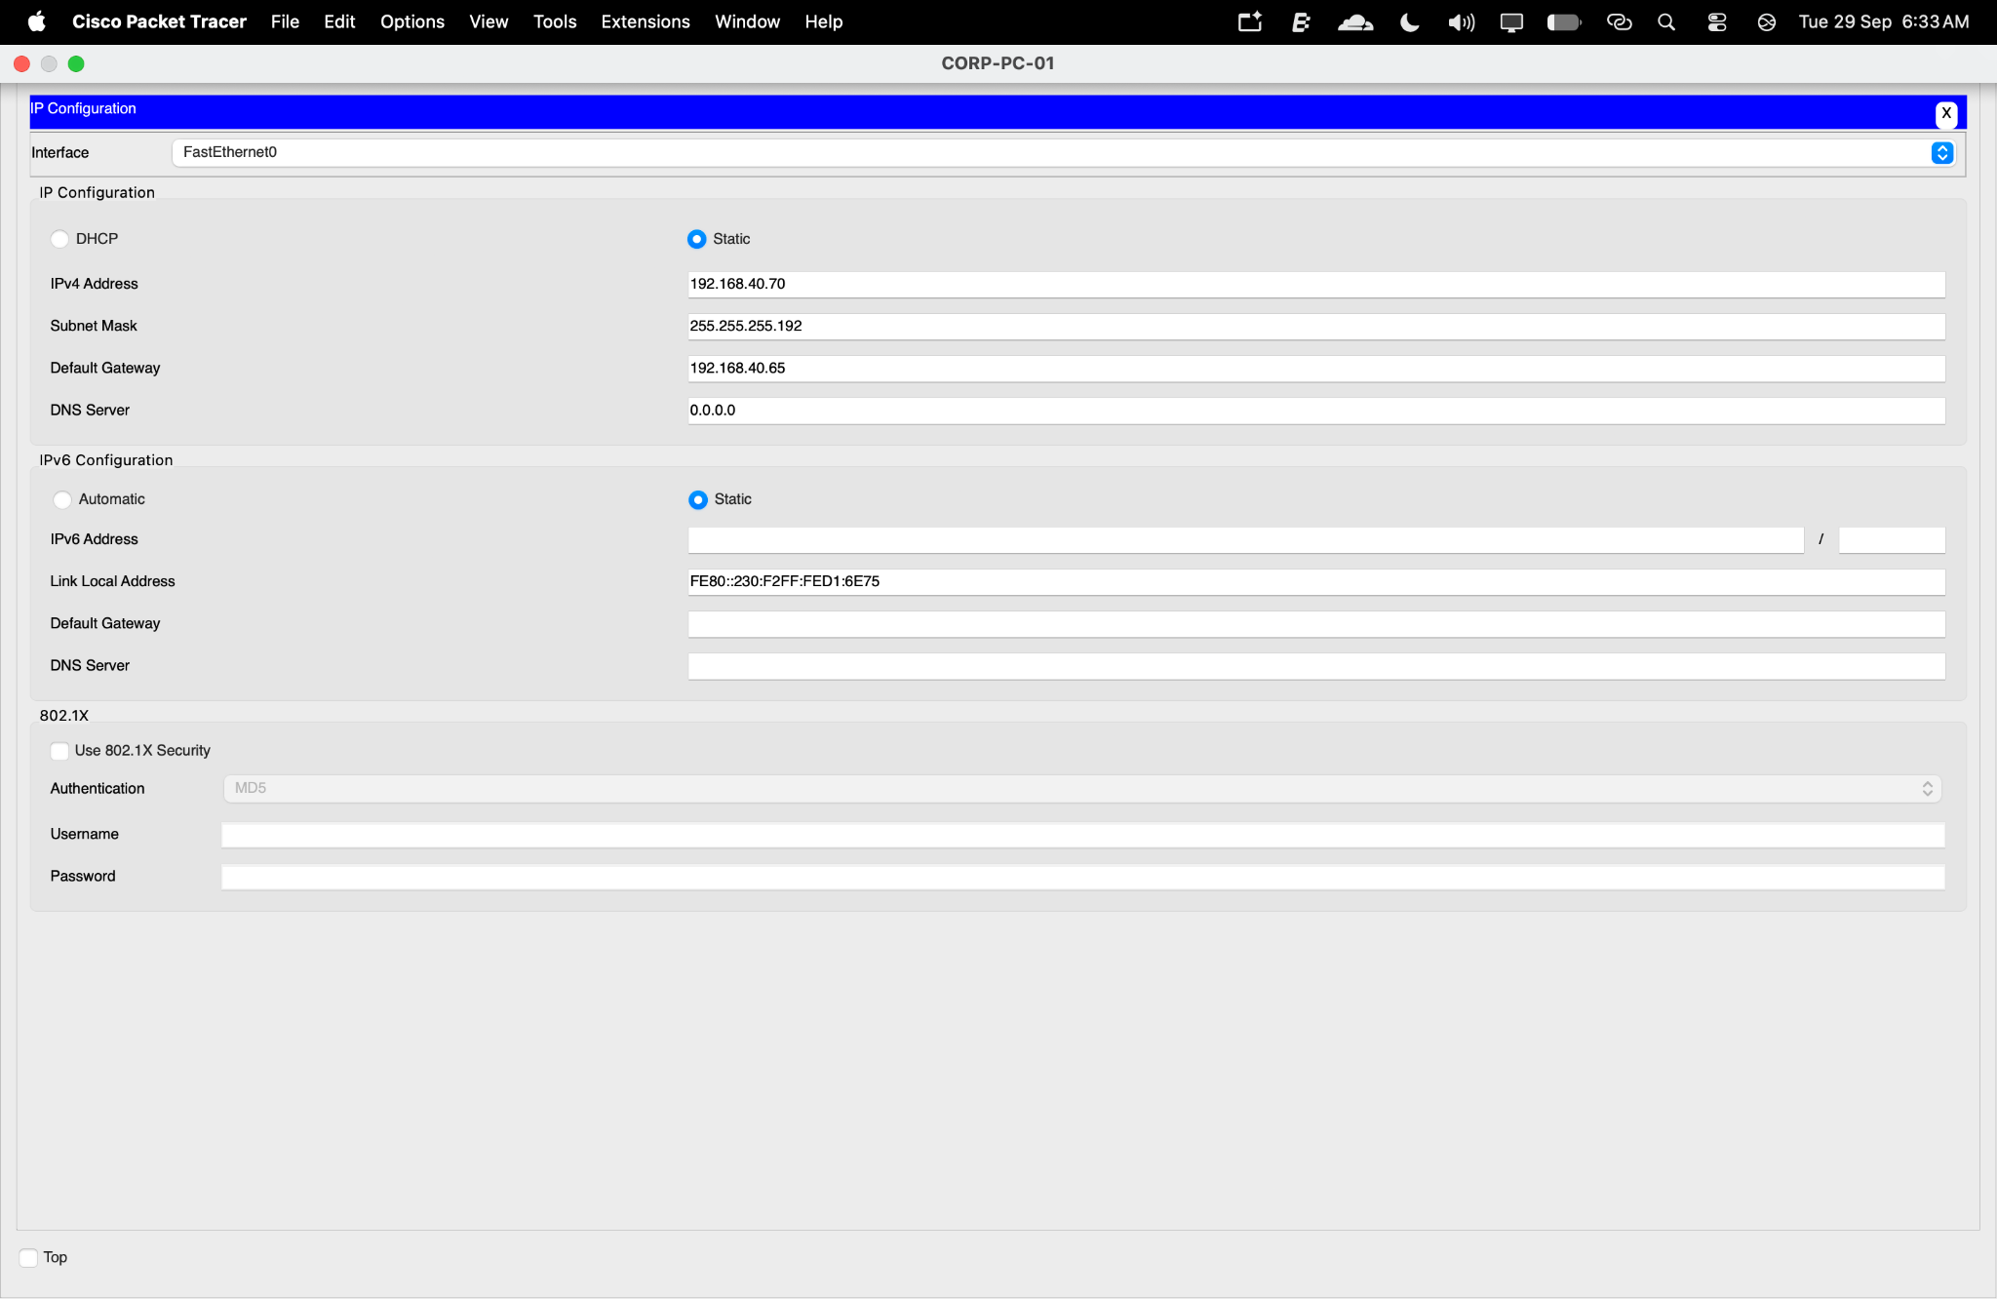
Figure 24: IP configuration of CORP-PC-01.

14.3 IT & Records Device
The IT file server was configured with:
Parameter | Value
Device | IT-File-Server
IP Address | 192.168.40.130
Subnet Mask | 255.255.255.240
Default Gateway | 192.168.40.129
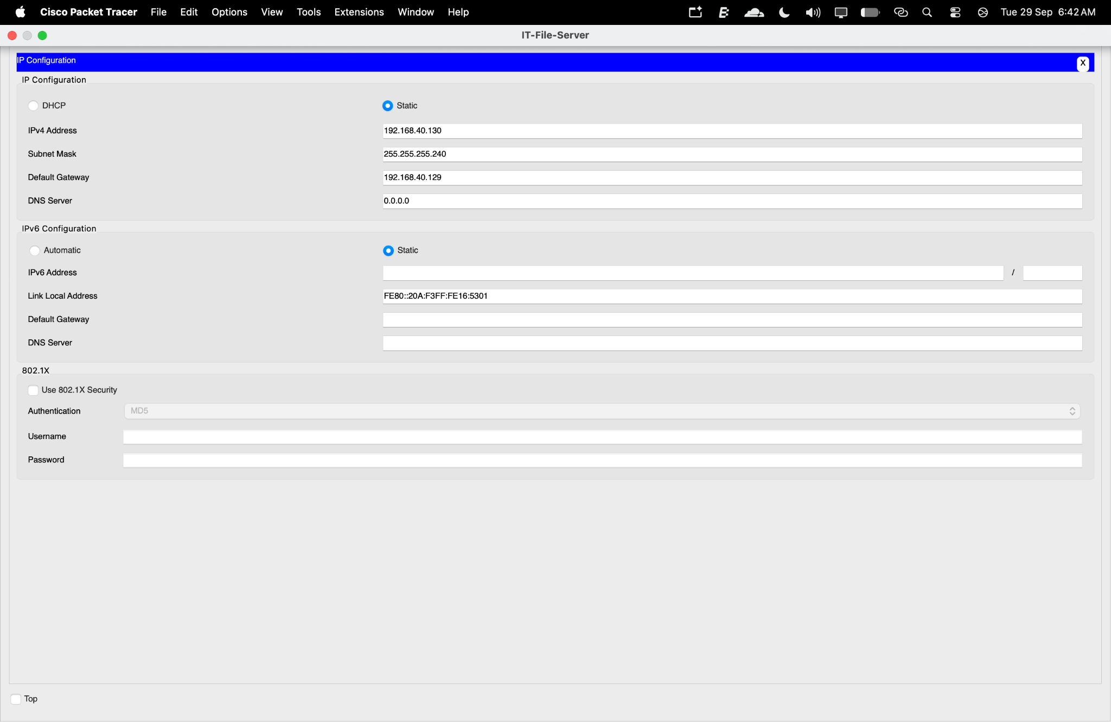
Figure 25: IP configuration of IT-File-Server.

14.4 Reception/Admin Device
The administrative PC was configured with:
Parameter | Value
Device | ADMIN-PC-01
IP Address | 192.168.40.146
Subnet Mask | 255.255.255.240
Default Gateway | 192.168.40.145
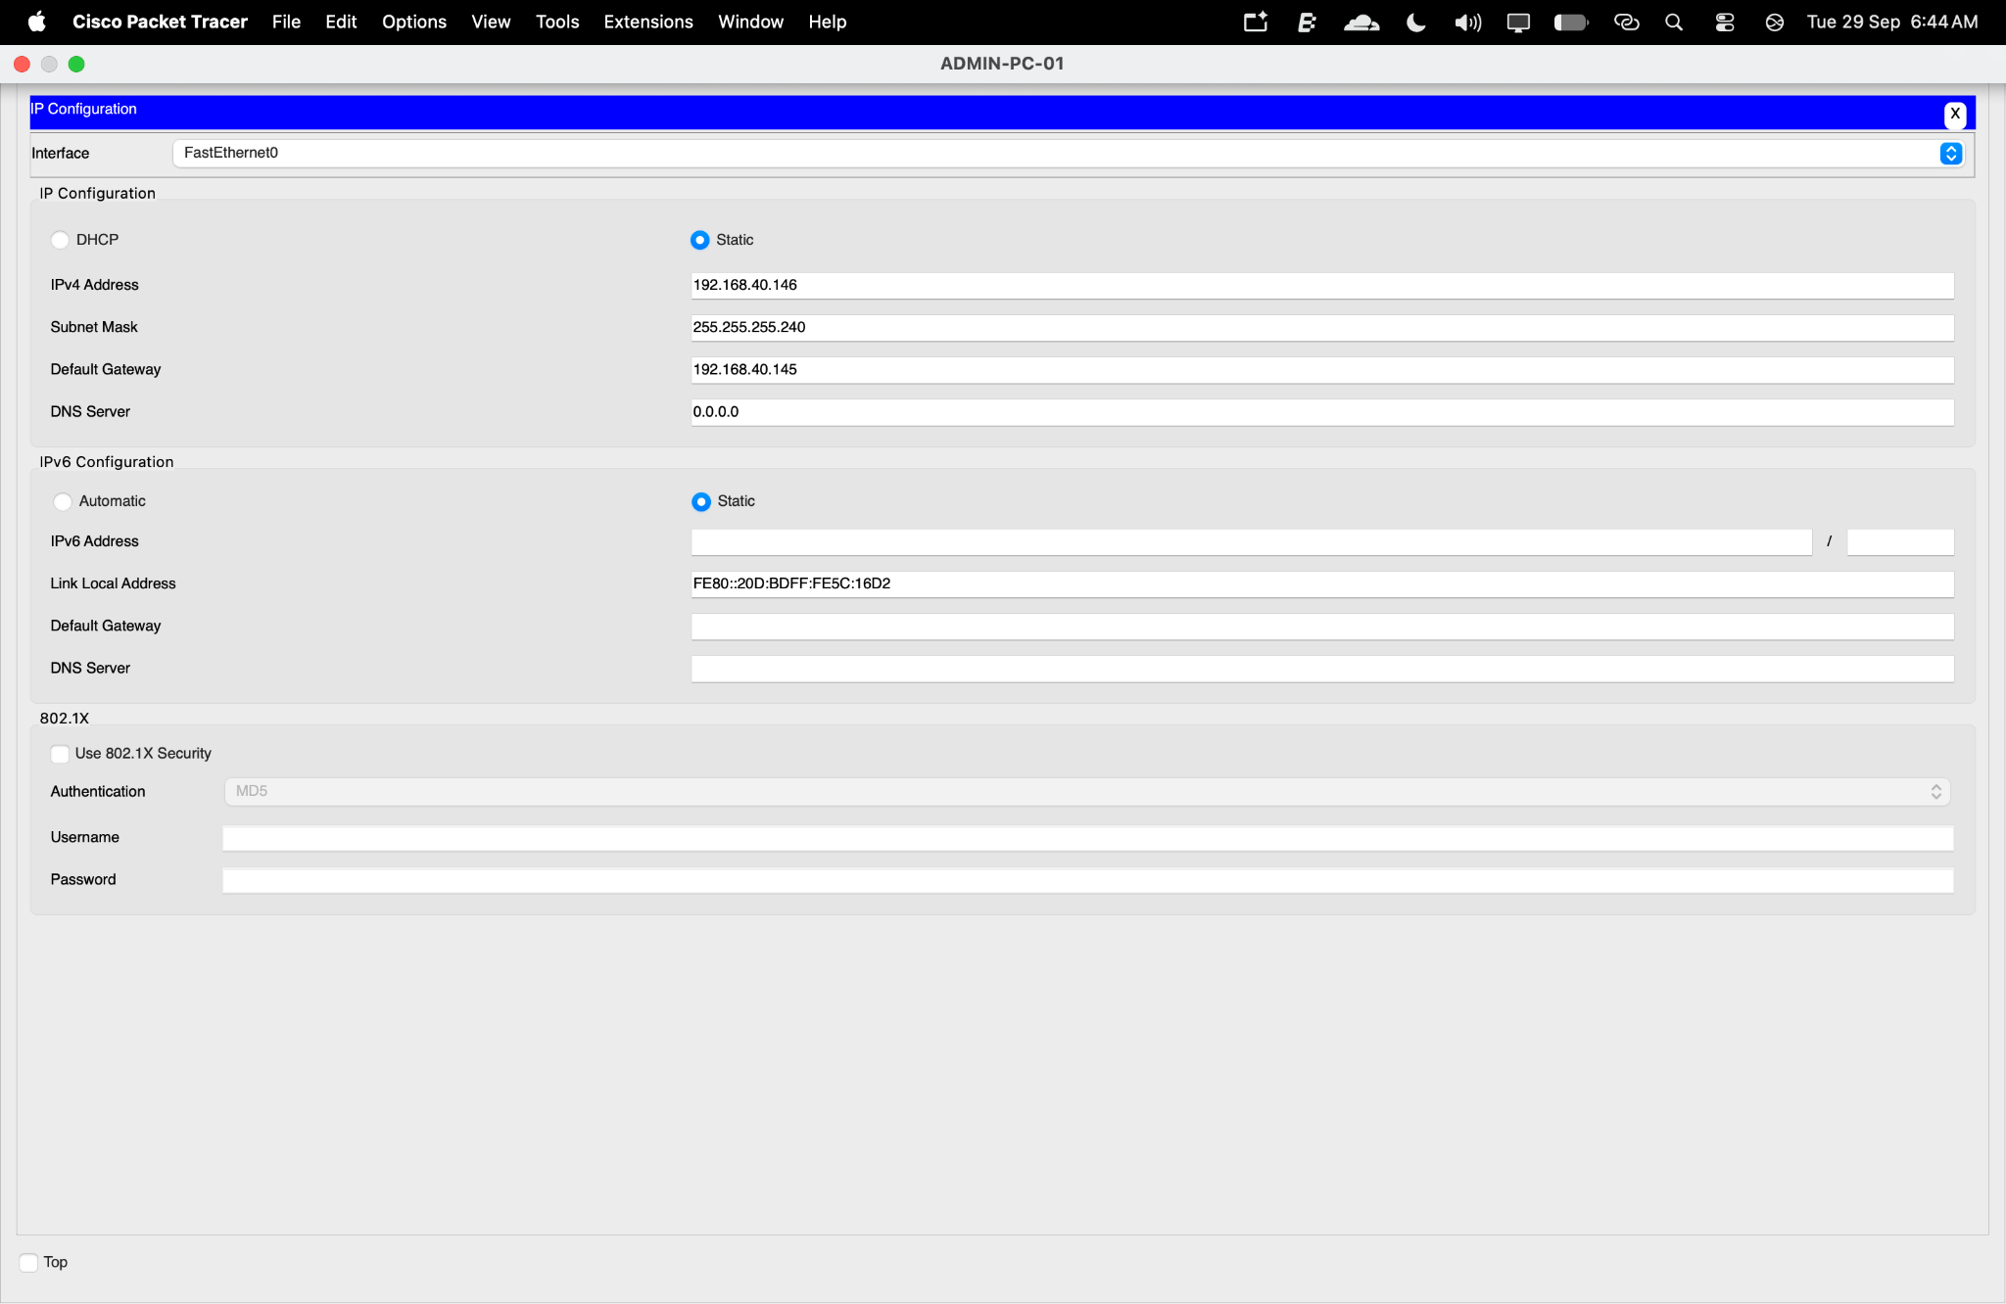
Figure 26: IP configuration of ADMIN-PC-01.

15. VOICE VLAN IMPLEMENTATION

15.1 Voice VLAN Creation
A dedicated Voice VLAN was implemented using:
VLAN ID: 50
VLAN Name: VOICE
This separates VoIP traffic from normal Reception/Admin data traffic.
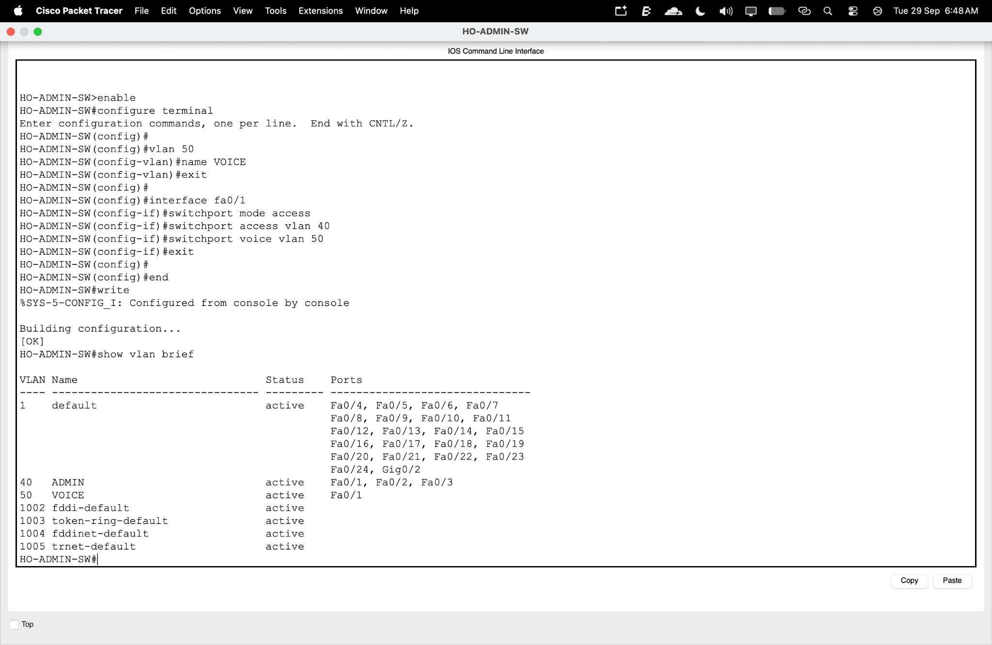
Figure 27: Voice VLAN 50 configuration on HO-ADMIN-SW.

15.2 Voice VLAN Router Subinterface
The Head Office router was configured with:
G0/0.50
IP Address: 192.168.40.161/28
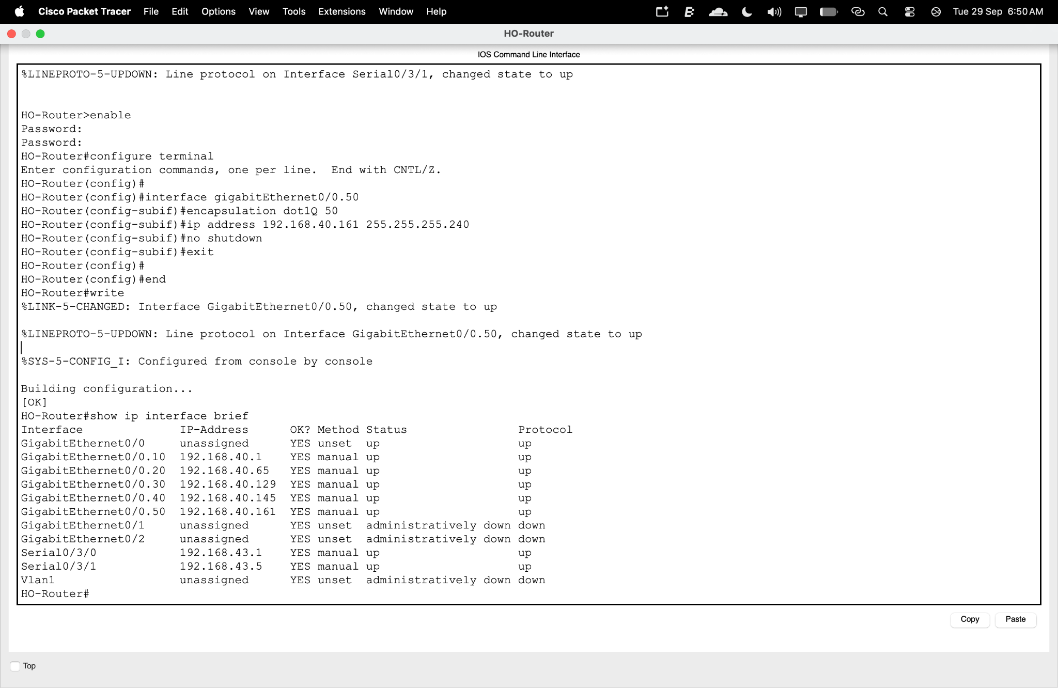
Figure 28: Router subinterface G0/0.50 for Voice VLAN 50.

15.3 Voice DHCP Pool
A DHCP pool named VOICE_POOL was configured for the Voice VLAN.
The available range is:
192.168.40.161 – 192.168.40.174
One address is excluded for gateway use, leaving the remaining addresses available for IP phones.
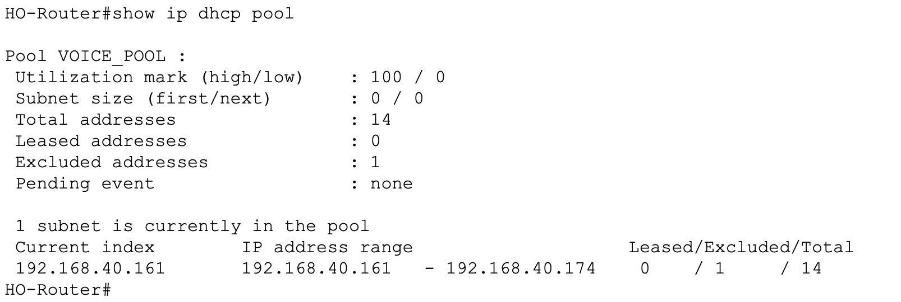
Figure 29: DHCP pool configuration for Voice VLAN 50.

15.4 IP Phone DHCP Assignment
The IP phone was configured to obtain its address automatically through DHCP.
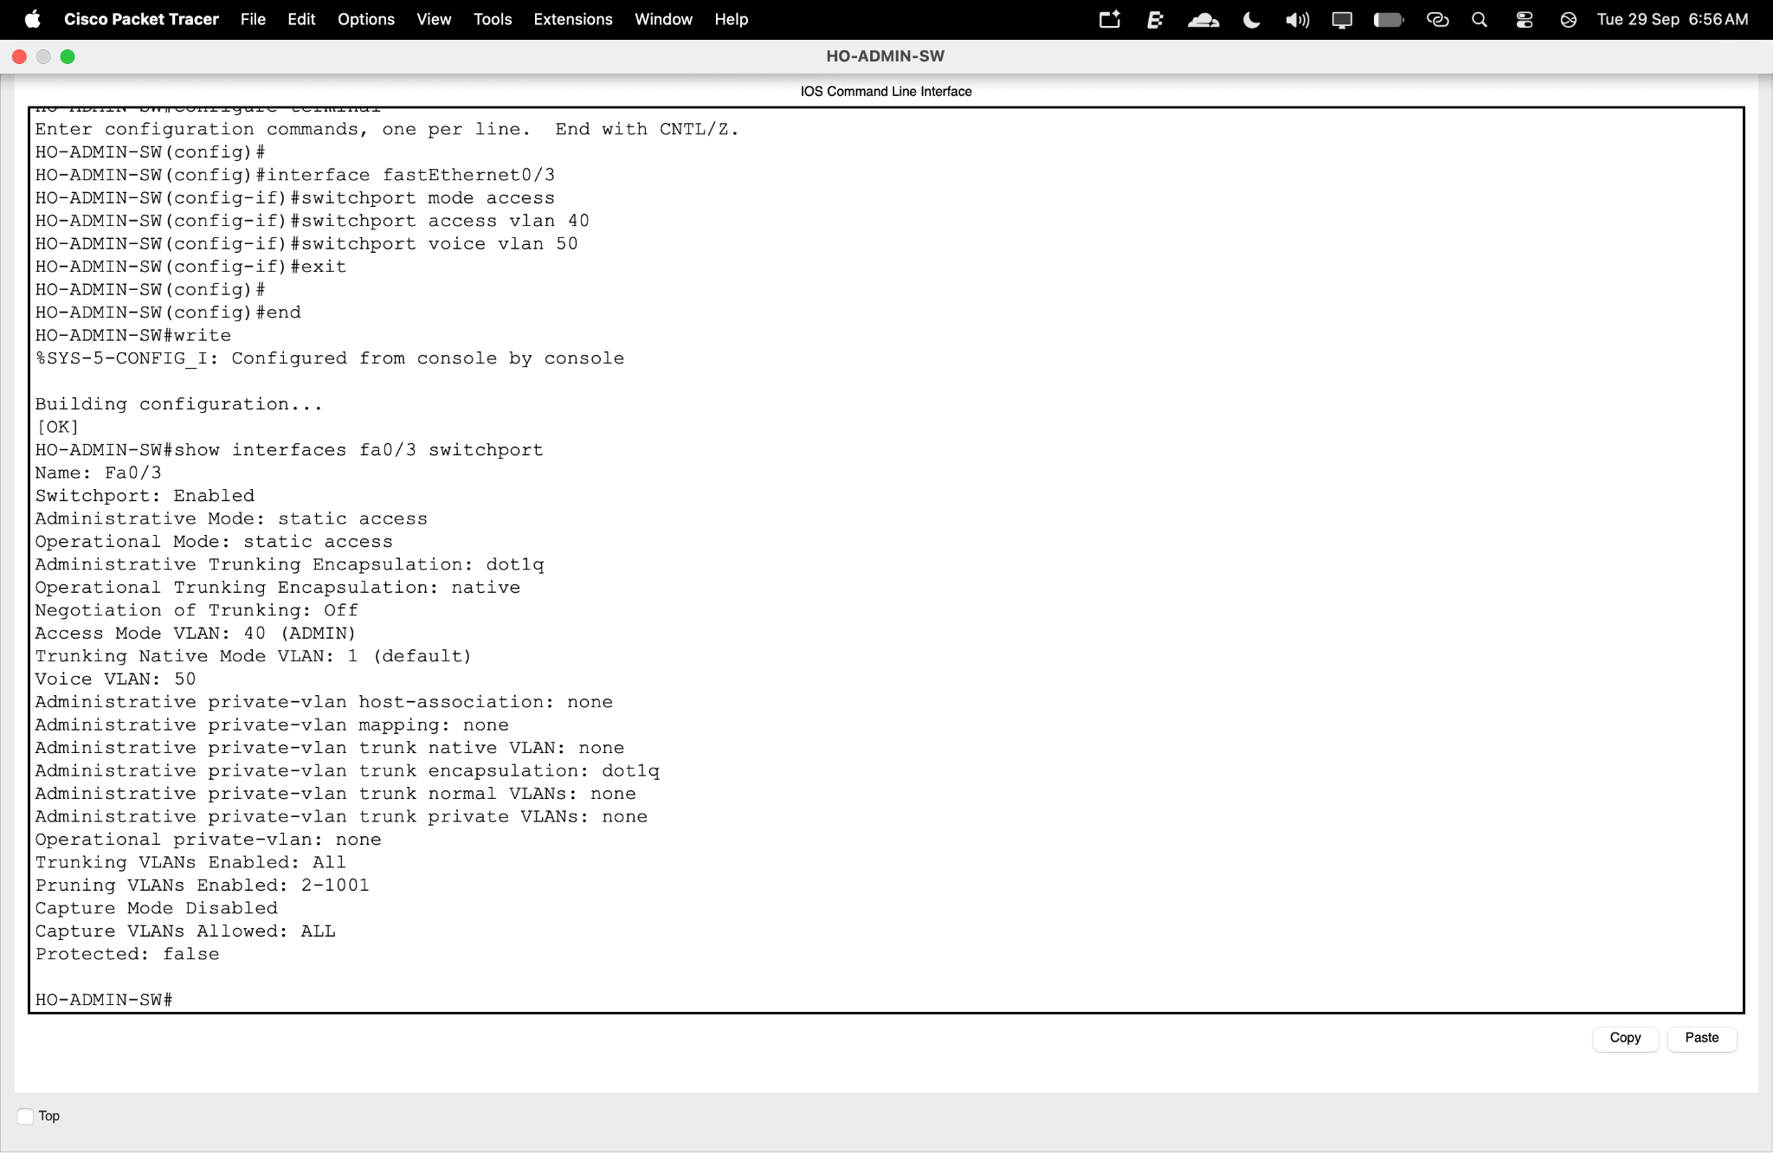
Figure 30: IP phone interface configured for DHCP.

15.5 DHCP Binding Verification
The DHCP binding table confirmed that the IP phone received:
192.168.40.162
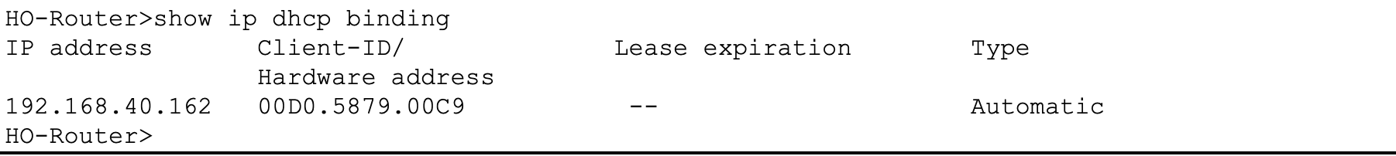
Figure 31: DHCP binding showing the IP address assigned to the IP phone.

16. NETWORK TESTING AND VERIFICATION
After configuration, the network was tested at multiple levels.

16.1 Litigation Gateway Test
The Litigation device successfully pinged its default gateway:
192.168.40.1
Result:
4/4 replies — 0% packet loss
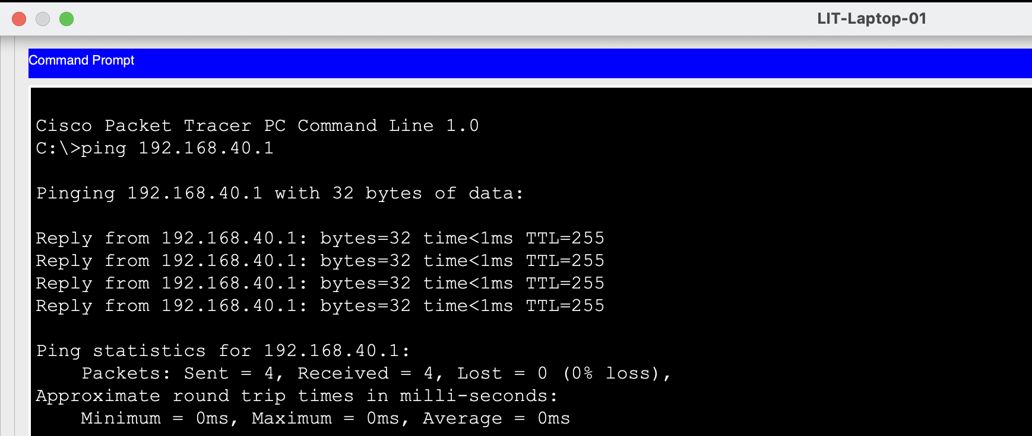
Figure 32: Successful Litigation gateway connectivity test.

16.2 Corporate Gateway Test
The Corporate PC successfully pinged:
192.168.40.65
Result:
4/4 replies — 0% packet loss
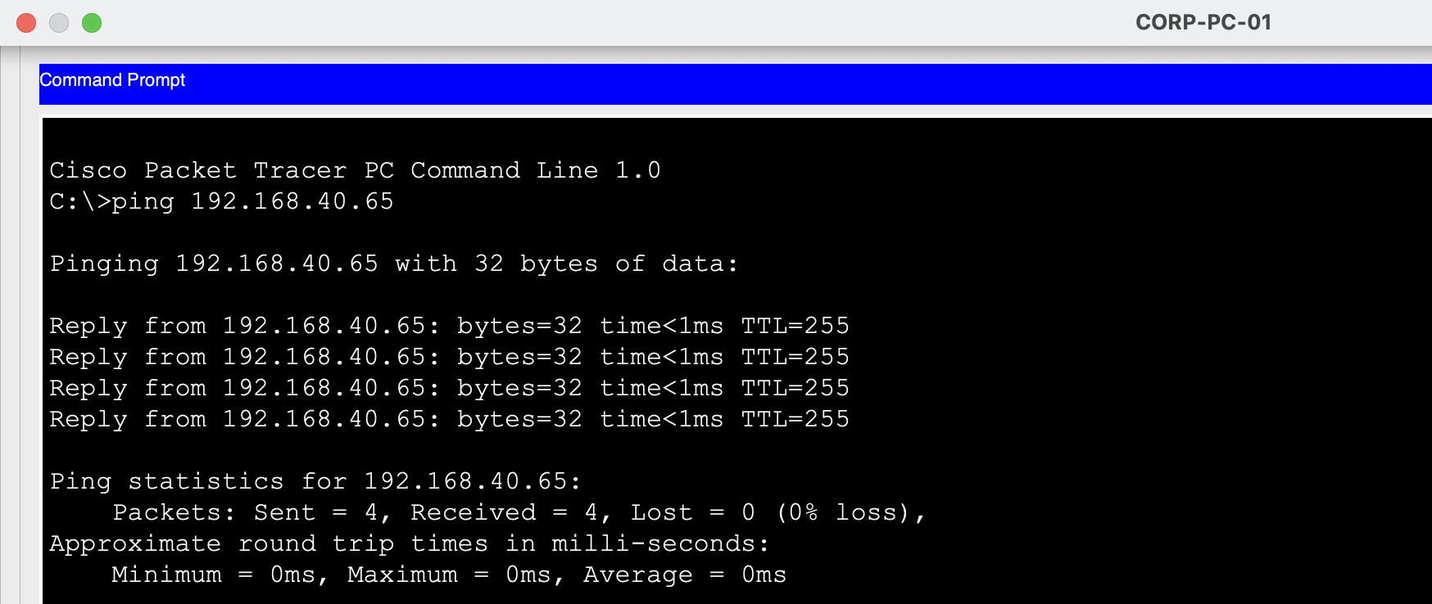
Figure 33: Successful Corporate gateway connectivity test.

16.3 IT Gateway Test
The IT file server successfully pinged:
192.168.40.129
Result:
4/4 replies — 0% packet loss
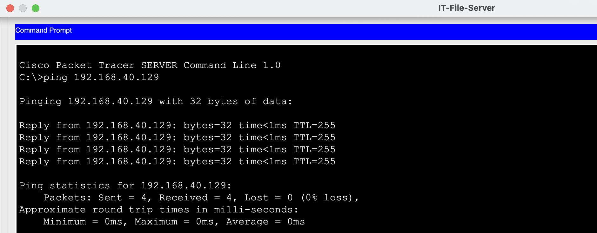
Figure 34: Successful IT & Records gateway connectivity test.

16.4 Admin Gateway Test
The Admin PC successfully pinged:
192.168.40.145
Result:
4/4 replies — 0% packet loss
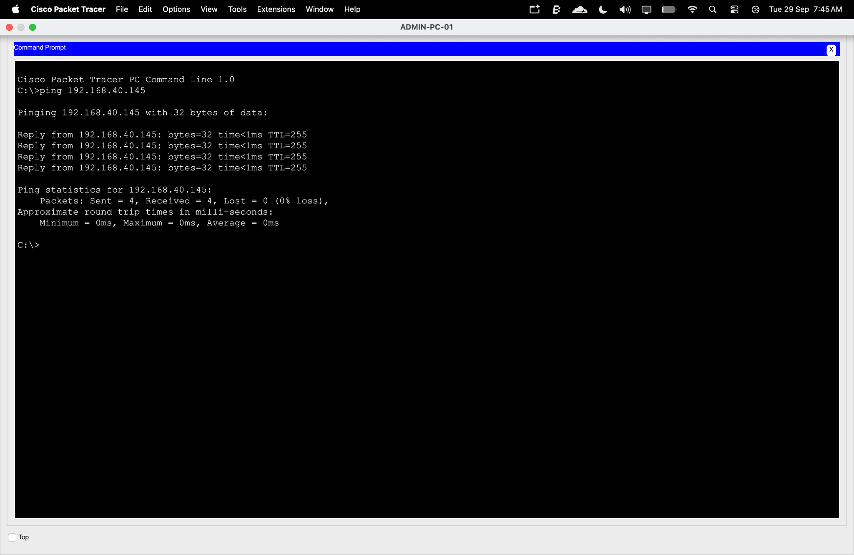
Figure 35: Successful Reception/Admin gateway connectivity test.

16.5 Inter-VLAN Test: Litigation to IT
The Litigation device successfully communicated with the IT file server:
Destination: 192.168.40.130
Result:
4/4 replies — 0% packet loss
This confirms that Router-on-a-Stick is providing communication between the Litigation and IT VLANs.
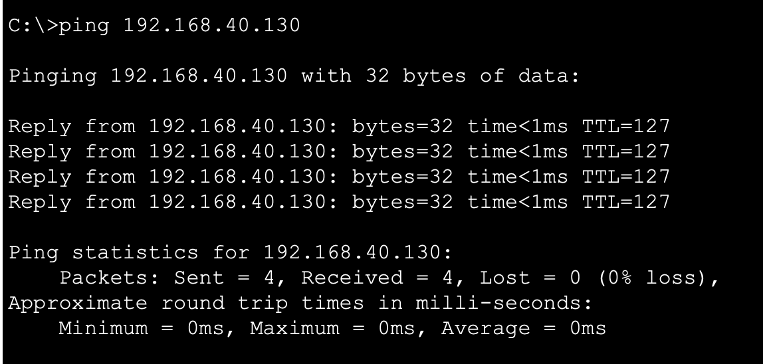
Figure 36: Successful inter-VLAN connectivity from Litigation to IT & Records.

16.6 Inter-VLAN Test: Admin to Corporate
The Admin device successfully communicated with the Corporate Law device:
Destination: 192.168.40.70
Result:
4/4 replies — 0% packet loss
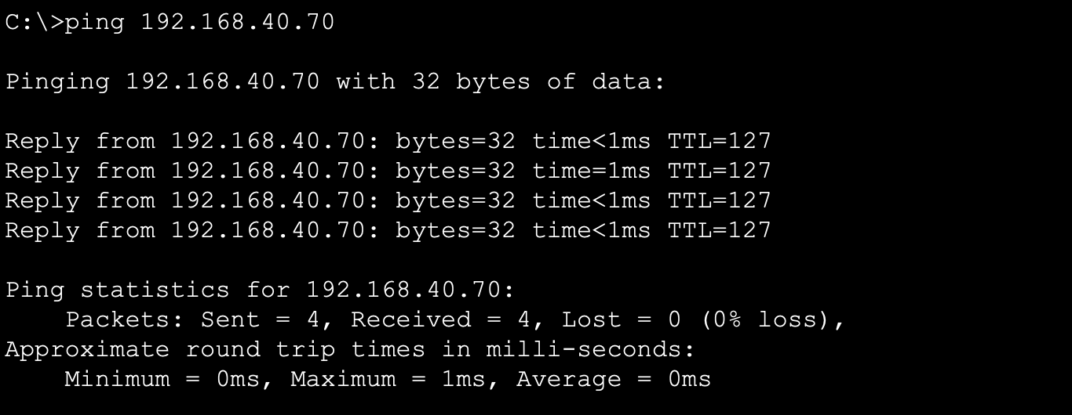
Figure 37:Successful inter-VLAN connectivity from Admin to Corporate Law.

16.7 WAN Test: Head Office to Riverside
The Head Office router successfully pinged:
192.168.43.2
Result:
100% successful
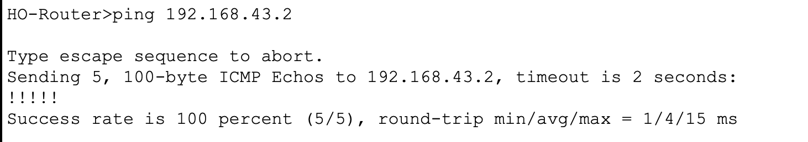
Figure 38: Successful WAN connectivity from HO-Router to Riverside-Router.

16.8 WAN Test: Head Office to Uptown
The Head Office router successfully pinged:
192.168.43.6
Result:
100% successful
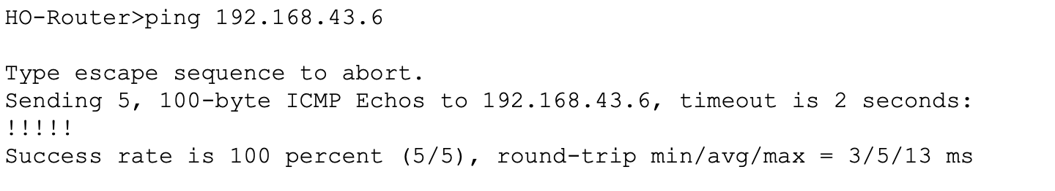
Figure 39: Successful WAN connectivity from HO-Router to Uptown-Router.

16.9 Routing Table Verification
The Head Office router routing table confirmed the directly connected VLAN networks and WAN networks.
Important connected networks include:
- 192.168.40.0/26
- 192.168.40.64/26
- 192.168.40.128/28
- 192.168.40.144/28
- 192.168.40.160/28
- WAN subnets under 192.168.43.0
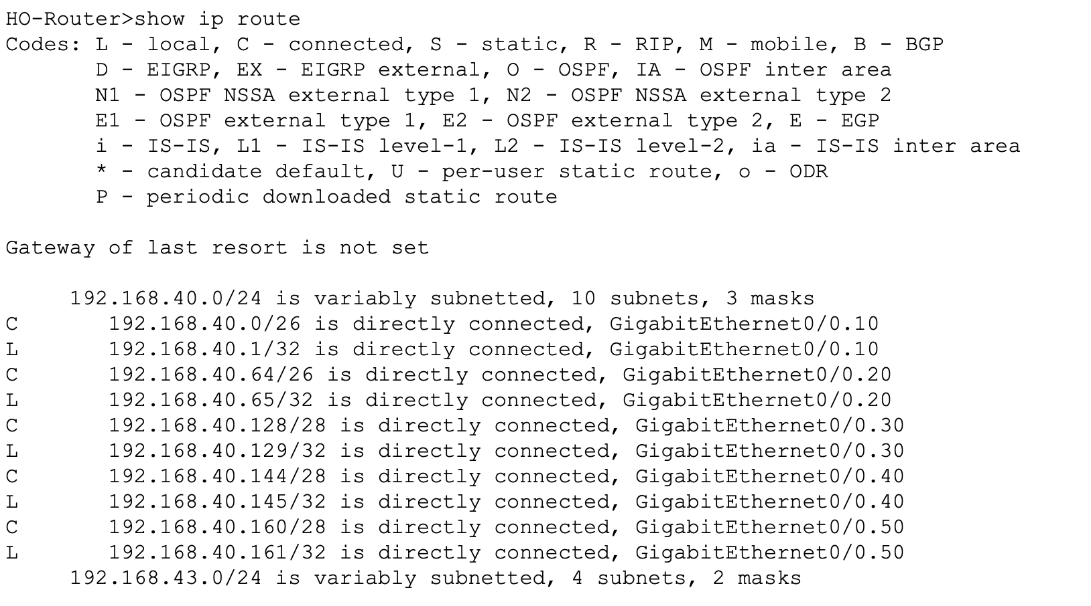
Figure 40: HO-Router routing table showing connected VLAN and WAN networks.

17. NETWORK PROTOCOL EXPLANATION

17.1 DHCP Process
Dynamic Host Configuration Protocol (DHCP) automatically provides network configuration information to devices.
The basic process is:
- DHCP Discover — The client broadcasts a request for an IP configuration.
- DHCP Offer — The DHCP server offers an available IP address.
- DHCP Request — The client requests the offered configuration.
- DHCP Acknowledgement — The DHCP server confirms the assignment.
In this project, DHCP was used for automatic IP assignment of the VoIP phone.

17.2 ARP Process
Address Resolution Protocol (ARP) maps an IPv4 address to the corresponding MAC address on a local network.
When a device needs to communicate:
- It checks its ARP cache.
- If the destination MAC address is unknown, an ARP request is broadcast.
- The device owning the requested IP address responds with its MAC address.
- The sender can then construct and transmit the Ethernet frame.
If the destination is on another network, the sender normally resolves the MAC address of its default gateway.

17.3 DNS Process
Domain Name System (DNS) translates human-readable hostnames into IP addresses.
For example:
Case-management portal hostname
↓
IP Address
DNS allows users to access services using names rather than remembering numerical IP addresses.

17.4 ICMP Process
Internet Control Message Protocol (ICMP) is used for network diagnostic and error-reporting functions.
The ping command uses ICMP Echo Request and Echo Reply messages.
A successful ping can verify:
- Reachability
- IP connectivity
- Basic routing
- Gateway availability

18. DHCP → ARP → DNS → ICMP SEQUENCE
When a new workstation is connected to the enterprise network and needs to access an internal case-management portal, several network processes may occur.
First, the workstation obtains its network configuration using DHCP. It broadcasts a DHCP Discover message, receives a DHCP Offer, sends a DHCP Request, and receives a DHCP Acknowledgement containing an IP address, subnet mask, default gateway, and other configuration information.
Next, the workstation may use ARP to determine the MAC address required for local communication. If the destination is outside the workstation's subnet, the workstation resolves the MAC address of its default gateway.
When the user enters the internal case-management portal hostname, DNS can translate that hostname into the corresponding server IP address.
After the destination IP address is known, normal application communication can begin. ICMP is not required for ordinary web browsing, but it is commonly used to verify connectivity using the ping command. A successful ICMP Echo Reply confirms basic IP reachability between the source and destination.
Therefore, DHCP provides configuration, ARP resolves local Layer 2 addressing, DNS resolves hostnames, and ICMP provides a useful diagnostic mechanism.

19. OSI / TCP-IP MODEL MAPPING
The following table maps common day-to-day network activities to the OSI and TCP/IP models.
Day-to-Day Activity | OSI Layer | TCP/IP Layer | Explanation
Lawyer accesses internal case-management portal | Layer 7 – Application | Application | Application protocols provide access to the portal service.
Switch forwards an Ethernet frame using MAC address | Layer 2 – Data Link | Network Access | The switch uses MAC addresses to forward frames.
Router forwards traffic to another office | Layer 3 – Network | Internet | IP addressing allows the router to select the destination network.
New workstation receives network configuration | Layer 7 – Application | Application | DHCP provides IP configuration to the client.
Administrator performs a ping test | Layer 3 – Network | Internet | ICMP is used to test IP reachability.

20. OSI LAYER DEVICE MAPPING
Device | Primary OSI Layer | Role in Project
End Devices | Layers 1–7 | Generate and receive application and network traffic
Access Switches | Layer 2 | VLAN and MAC-based frame forwarding
Core Switch | Layer 2 | Central switching and VLAN trunk connectivity
Router | Layer 3 | Inter-VLAN routing and WAN connectivity
Serial WAN Interface | Layers 1–2 | Physical and data-link communication over serial connection
The switches primarily operate at Layer 2 in this implementation, while the Head Office router performs the Layer 3 routing function.

21. PRIVATE AND PUBLIC IP ADDRESSING
The implemented internal network uses private IPv4 addressing.
The primary internal address space is:

192.168.40.0/22
The WAN point-to-point links also use private addresses:
- 192.168.43.0/30
- 192.168.43.4/30
These addresses belong to the private IPv4 address range 192.168.0.0/16.
Private addresses are appropriate for internal organizational networks because they are not directly routable over the public Internet.

Advantages of Private Addressing
- Conserves globally routable public IPv4 addresses
- Provides an organized internal addressing structure
- Supports internal network segmentation
- Allows address reuse within private networks
- Works well with NAT when Internet access is required

Private WAN Addressing
Using private IP addresses on the point-to-point WAN links is appropriate because the leased connections are used for communication between the organization's routers.
However, private addressing itself should not be considered encryption. Security controls such as ACLs, firewalls, authentication, or encryption may be required depending on the organization's security requirements.
If Internet connectivity is introduced in the future, public addressing can be used at the appropriate edge interface, generally together with NAT/PAT.

22. COMPLETE IP ADDRESSING SUMMARY

22.1 Head Office VLAN Gateways
VLAN | Name | Network | Gateway | Mask
10 | LITIGATION | 192.168.40.0/26 | 192.168.40.1 | 255.255.255.192
20 | CORPORATE | 192.168.40.64/26 | 192.168.40.65 | 255.255.255.192
30 | IT | 192.168.40.128/28 | 192.168.40.129 | 255.255.255.240
40 | ADMIN | 192.168.40.144/28 | 192.168.40.145 | 255.255.255.240
50 | VOICE | 192.168.40.160/28 | 192.168.40.161 | 255.255.255.240

22.2 Router Interfaces
Device | Interface | IP Address
HO-Router | G0/0.10 | 192.168.40.1/26
HO-Router | G0/0.20 | 192.168.40.65/26
HO-Router | G0/0.30 | 192.168.40.129/28
HO-Router | G0/0.40 | 192.168.40.145/28
HO-Router | G0/0.50 | 192.168.40.161/28
HO-Router | S0/3/0 | 192.168.43.1/30
HO-Router | S0/3/1 | 192.168.43.5/30
Riverside-Router | S0/1/0 | 192.168.43.2/30
Uptown-Router | S0/1/0 | 192.168.43.6/30

22.3 Tested End Devices
Device | IP Address | Mask | Gateway
LIT-Laptop-01 | 192.168.40.10 | /26 | 192.168.40.1
CORP-PC-01 | 192.168.40.70 | /26 | 192.168.40.65
IT-File-Server | 192.168.40.130 | /28 | 192.168.40.129
ADMIN-PC-01 | 192.168.40.146 | /28 | 192.168.40.145
IP Phone | 192.168.40.162 | /28 | 192.168.40.161

23. FINAL NETWORK TOPOLOGY
After completing the configurations and verification tests, the complete enterprise network topology was captured.
The final implementation contains:
- Head Office
- Litigation Department
- Corporate Law Department
- IT & Records Department
- Reception/Admin Department
- Voice VLAN
- Head Office router
- Core switch
- Departmental access switches
- Riverside branch
- Uptown branch
- Serial WAN connections
- End-user devices
- Printers
- IP phone
- VLAN segmentation
- Inter-VLAN routing
- WAN connectivity

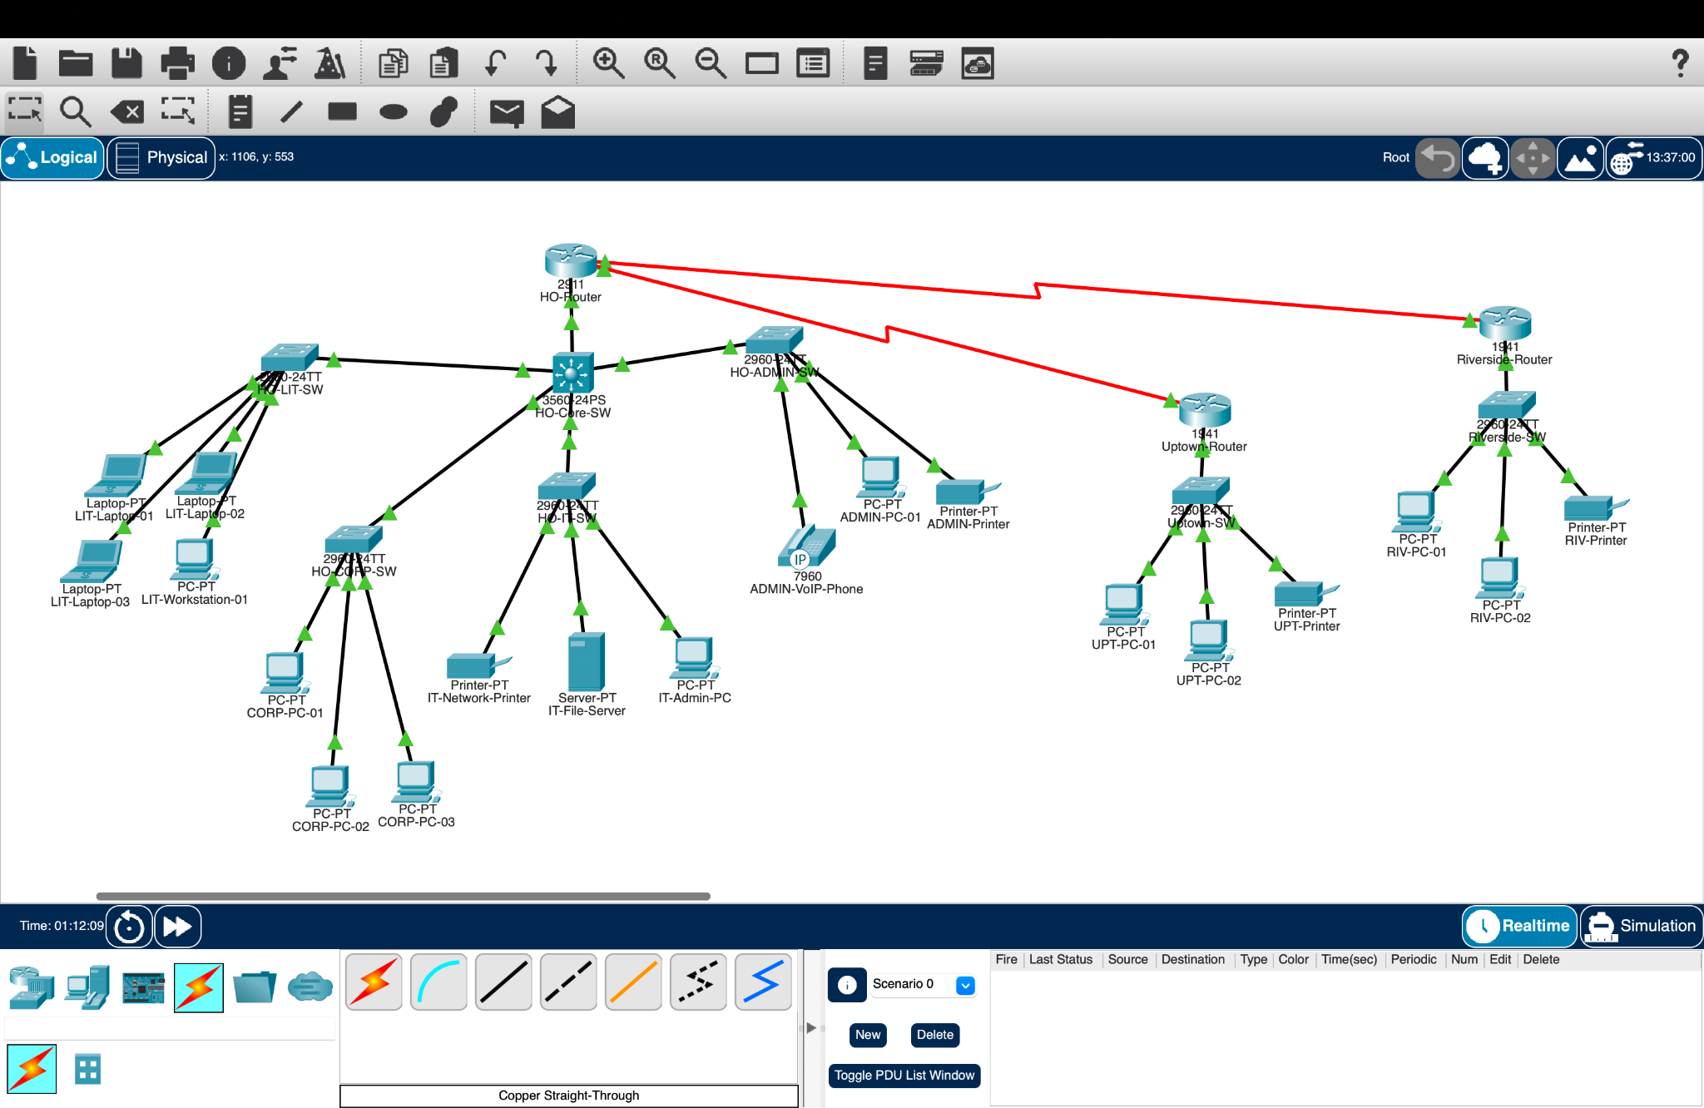
Figure 41: Final completed Harbor Lane Legal Group network topology showing the Head Office, Riverside branch, Uptown branch, VLAN-based departmental segmentation, WAN links, and connected end devices.
This screenshot should preferably be placed on its own page because it is the final logical network diagram and is one of the most important figures in the report.

24. CONCLUSION
The enterprise network for Harbor Lane Legal Group was successfully designed and implemented using Cisco Packet Tracer.
The project implemented departmental VLAN segmentation, VLSM-based IP addressing, Router-on-a-Stick inter-VLAN routing, trunk connectivity, Voice VLAN functionality, DHCP-based IP assignment for the IP phone, and serial WAN connectivity between the Head Office and branch offices.
The addressing plan was designed using the 192.168.40.0/22 base network and divided using VLSM according to the host requirements. Appropriate subnet sizes were selected for the Litigation, Corporate Law, IT & Records, Reception/Admin, Voice, and point-to-point WAN networks.
The implementation was verified using gateway ping tests, inter-VLAN connectivity tests, WAN ping tests, DHCP binding verification, and routing-table inspection. The successful test results demonstrate that the configured network components are communicating according to the implemented design.
The final topology provides a structured and scalable foundation for the organization's network requirements.

25. FUTURE IMPROVEMENTS
The implemented network can be further enhanced with additional enterprise networking and security technologies.
Possible future improvements include:
- Firewall implementation
- Access Control Lists (ACLs)
- Wireless network infrastructure
- Network monitoring
- Redundant network links
- Dynamic routing protocols such as OSPF
- Centralized authentication
- Network logging and monitoring
- Backup connectivity
- Additional security policies
These improvements can further strengthen network security, reliability, manageability, and scalability.

END OF REPORT

